BUILDING CONTROL OFFICER
Position Title | Building Control Officer
Group | Planning and Regulatory
Location | Carterton
Reports to | Building Services Team Leader
Direct Reports | Nil
Delegated Authority | As per Delegations Manual
Employment Status | Permanent

Role of the Planning and Regulatory Team
The Planning and Regulatory Team carries out the planning, building control, and regulatory functions of Carterton District Council, and provides strategic and policy advice across Council’s activities.

Purpose of the Role
To deliver technically sound, customer-focused building control services for Carterton District Council, including consent processing, inspections, Code Compliance Certificate recommendations, compliance investigations and related Territorial Authority functions, so building work in the district is safe, compliant, durable and consistent with the Building Act 2004, Building Code, Building Regulations, Council policies and the BCA Quality Management System.

Responsibilities
- Deliver Building Consent Authority and Territorial Authority functions within approved competency levels, delegations, statutory timeframes, Council procedures and the BCA Quality Management System.
- Undertake consent processing, inspections, Code Compliance Certificate recommendations, compliance investigations and related building control activities in accordance with the Building Act 2004, Building Code, Building Regulations and associated statutes.
- Provide clear, impartial and practical technical advice to customers, applicants, owners, designers, contractors, colleagues and other stakeholders while maintaining regulatory independence.
- Maintain accurate, complete and auditable records that support sound regulatory decision-making, quality assurance, continuous improvement and BCA accreditation outcomes.

Organisational Context
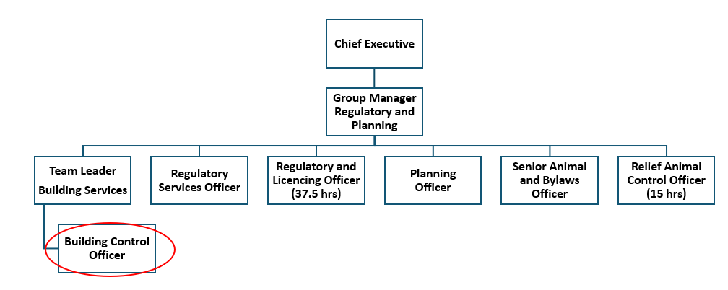

Working Relationships
The Building Control Officer reports directly to the Building Services Team Leader.
Additionally, the role will have contact with a number of internal and external contacts including, but not limited to:

Internal Relationships | External Relationships
- Customer and Regulatory Services Manager  - Members of the Building Team  - Building Administrator  - Planning team members  - All other members of staff | - Members of the building industry  - Regional Building Cluster members  - Contractors to the Building Consent Authority  - Building, plumbing and drainage tradespeople  - Architects, engineers and other design professionals  - Commercial building owners, occupiers and property developers  - Ratepayers and residents of Carterton District  - Other territorial authorities and government departments  - Fire and Emergency New Zealand
Key Result Areas
Key Result Area | Deliverable Measures
Consent Processing and Technical Assessment | - Assess building consent applications, amendments, exemptions, Certificates of Acceptance and related documentation within approved competency levels and delegations.  - Review plans, specifications, producer statements, engineering information and compliance pathways, including Acceptable Solutions, Verification Methods and Alternative Solutions.  - Prepare clear, proportionate and technically justified Requests for Information when further information is required.  - Document assessment decisions so they are accurate, auditable and defensible under the Building Act, Building Code and BCA Quality Management System.
Inspections, Code Compliance Certificates and Field Work | - Carry out building, plumbing and drainage inspections within approved competency levels and in accordance with approved inspection checklists and procedures.  - Confirm work has been completed in accordance with approved building consent documentation and relevant Building Code requirements.  - Record inspection outcomes promptly and accurately, including photographs, notes, failed items and follow-up requirements.  - Make recommendations on Code Compliance Certificates, compliance schedules and related matters within delegated authority, escalating complex or high-risk matters as required.
Compliance, Enforcement and Territorial Authority Functions | - Investigate complaints about unauthorised, non-compliant, dangerous, affected or insanitary building work and prepare high-quality investigation records.  - Apply Council policy, approved delegations and enforcement principles when recommending or issuing Notices to Fix, infringement notices or other enforcement action.  - Support swimming pool barrier, compliance schedule, building warrant of fitness, earthquake-prone building and post-event building assessment functions as required by Council priorities and competency.  - Prepare evidence, reports and recommendations that are complete, fair, legally robust and suitable for escalation where necessary.
Customer, Industry and Stakeholder Service | - Provide clear, consistent, practical and impartial technical advice to customers, applicants, designers, builders, owners and internal teams.  - Communicate decisions and requirements in plain language while maintaining regulatory independence and professional boundaries.  - Build constructive relationships with regional BCA cluster members, Fire and Emergency New Zealand, contractors, other councils and industry stakeholders.  - Help customers understand consenting, inspections and compliance processes, including timeframes, Requests for Information and documentation expectations.

Health, Safety & Wellbeing | - Actively participate in Health, Safety and Wellbeing (HS&W) activities.  - Demonstrate understanding of HS&W related policies and procedures.  - Always be accountable for own actions while adhering to the Health and Safety at Work Act 2015.  - Actively raise awareness of HS&W in the workplace.  - Actively participate in safety reporting and hazard management.  - Demonstrate HS&W practices to colleagues.
Council Contribution | - Deliver on overall Council contribution to ensure Council's overall business goals are achieved, as well as developing own professional abilities on a continuous basis.  - Demonstrate a collaborative working style and participate as a member of the team, undertaking all tasks while maintaining positive working relationships with staff and internal and external stakeholders.  - Act as an ambassador for Council and its services.  - Contribute to the promotion of the principles of Te Tiriti o Waitangi and work in partnership with Māori.  - Always act within professional guidelines and Council policies.  - Participate in Council's emergency preparation, training and response as practicable, including working with the Emergency Operations Centre when directed.  - Actively participate in and contribute to performance improvement and development.  - Participate in and contribute to management support initiatives.  - Additional tasks, duties or responsibilities as directed by the Building Services Team Leader.

Qualifications, Skills, Experience, Knowledge and Ability
Essential
- A relevant recognised technical qualification for building control work, or active progress toward one within an agreed timeframe, consistent with Regulation 18 requirements where applicable.
- Working knowledge of the Building Act 2004, Building Code, Building Regulations, BCA accreditation requirements and the building consent and inspection process.
- Building design, construction, plumbing and drainage, or related industry knowledge appropriate to the role level.
- Ability to read and interpret plans, specifications, technical documents, legislation and standards.
- Clear written and verbal communication skills, including the ability to explain technical matters in plain language.
- Sound judgement, independence, attention to detail and confidence making evidence-based regulatory decisions.
- High level of personal organisation, workload management and digital record keeping.
- Current full New Zealand driver licence.
- The ability to meet the physical demands of the role, including:
  - Ability to navigate uneven terrain, scaffolding, and construction zones safely
  - Physical stamina and balance to perform work at heights
  - Capacity to lift and carry inspection tools and equipment as necessary
Desired
- New Zealand Diploma in Building Surveying Level 6, National Diploma in Building Control Surveying, or another recognised Regulation 18 qualification.
- Competency to process and/or inspect residential and commercial work, for example R1/R2/R3 and C1/C2/C3, aligned with Council’s competency framework.
- Experience in a local government BCA or comparable regulatory environment.
- Experience with online consenting systems, mobile inspection technology and quality assurance environments.
- BOINZ membership, relevant continuing professional development, or specialist knowledge in compliance schedules, building warrants of fitness, pools, dangerous or insanitary buildings, or post-disaster assessment.
Our Values
 | - Respect in the glue that holds us together  - People are at the heart of everything we do  - It’s okay to disagree; what matters is that we respect each other
 | - We take responsibility, without excuses and hold each other accountable  - We get the job done  - We do the right thing, even when no one is looking
 | - We stand together; we put “we” before “I”  - We’ve got each other’s backs  - Different views, stronger together
 | - We think outside the box  - We’re open to new ideas that benefit our community  - We work together for the greater good

Our Competency Framework
The Carterton District Council Competency Framework defines a set of competencies and what success looks like at an organisational level and provides a benchmark for evaluating performance and identifying skill gaps. Our framework includes:
- Core competencies
- A descriptor for each competency
- Organisational levels so that all positions within CDC are part of the framework
- Examples of what success looks like at each level

These also link to our values.
This position sits at Level 2 of the Carterton District Council Competency Framework.
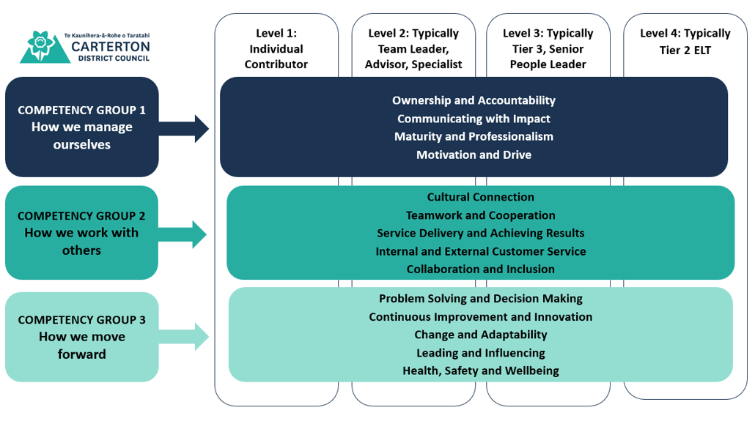

Competency and its definition | Behavioural Descriptors
Ownership and Accountability  The commitment to taking responsibility for own actions, decisions, and their consequences | Embraces ownership of role responsibilities, ensuring high-quality results. Identifies potential challenges proactively, taking initiative to find solutions and learn from experiences. Accepts responsibility for outcomes (positive or negative) of own work. Self-reflects.
Communicating with Impact  The ability to convey messages clearly and persuasively while engaging the audience, ensuring the intended meaning is understood by listeners | Communicates complex ideas effectively to a variety of audiences, utilising tailored communication as needed. Engages in active listening and provides constructive feedback to enhance discussions and outcomes.
Maturity and Professionalism  The ability to act and interact in a responsible and respectful manner, displaying emotional intelligence and a commitment to personal and organisational values | Exhibits a high level of professionalism by consistently delivering quality work and adhering to ethical standards. Navigates workplace challenges with maturity, demonstrating emotional intelligence and a thoughtful approach to problem-solving. Maintains composure in stressful situations and manages emotions appropriately.
Motivation and Drive  The ability to take action, pursue goals, and maintain persistence in the face of challenges. Setting high standards for oneself and inspiring others to achieve their best and get things done. | Exhibits a strong commitment to achieving results and overcoming challenges. Motivates peers through knowledge sharing and support, actively seeking opportunities to enhance skills and drive team performance towards shared objectives. Takes initiative to identify opportunities and tackle challenges without waiting for direction.
Cultural Connection  Understanding, respecting, and effectively engaging with Māori, fostering positive relationships, and promoting inclusivity, demonstrating knowledge of the Te Tiriti o Waitangi, te reo Māori and tikanga Māori | Applies knowledge of Māori culture and practices to enhance service delivery and community engagement. Collaborates with stakeholders to develop culturally appropriate solutions and actively promotes cultural awareness within council.
Teamwork and Cooperation  Working collaboratively with others toward a common goal, leveraging diverse skills and perspectives while fostering a supportive and inclusive environment | Works collaboratively within and across teams, leveraging expertise to enhance group outcomes. Shares knowledge and skills, supports colleagues in problem-solving, and actively engages in team discussions to drive innovation and efficiency.
Service Delivery and Achieving Results  Setting and delivering on priorities, goals, timetables and quality standards. A drive for achieving results. | Delivers results by applying specialised knowledge and skills to ensure work is completed on time and within scope. Proactively identifies potential obstacles and implements solutions to enhance productivity and effectiveness. Actively seeks out relevant information related to role. Ensures workflow is as effective and efficient as possible.
Internal and External Customer Service  Meeting the needs and expectations of internal (colleagues) and external (community members, customers, or other stakeholders) customers, ensuring satisfaction and positive relationships. | Understands and addresses the unique needs of internal customers, external customers, community stakeholders, and ratepayers. Collaborates with colleagues to create effective solutions and enhances service delivery, actively seeking feedback to improve the experience for all parties.
Competency and its definition | Behavioural Descriptors
Collaboration and Inclusion  Fostering an environment where everyone feels valued, respected, and empowered to contribute to shared goals. | Facilitates collaboration among colleagues and stakeholders by promoting open communication and mutual respect. Recognises and values diversity in the workplace, actively seeking input from various perspectives to inform decisions and improve outcomes.
Problem Solving and Decision Making  Identifying, analysing, and finding solutions to issues or challenges.  The process of selecting a course of action from multiple options, to achieve a specific or solve a problem. | Analyses complex issues and develops practical solutions based on data and expertise. Collaborates with team members to evaluate options and make informed decisions that align with project goals and council standards.
Continuous Improvement and Innovation  The ongoing effort to enhance processes or services through incremental improvements and creative thinking, fostering a culture that encourages new ideas. | Identifies opportunities for innovation within their area of expertise and contributes ideas for process improvements. Analyses trends and best practices, applying them to enhance performance and drive quality in deliverables.
Change and Adaptability  Effectively responding to and managing change, demonstrating flexibility, resilience, and a proactive approach to challenges and opportunities. | Effectively navigates changes within council, proactively seeking to understand current trends and developments. Adapts strategies and approaches to ensure continued success, while supporting colleagues through transitions.
Leading and Influencing  Guiding and motivating others toward achieving goals; shaping others' thoughts, behaviours, or decisions through persuasion and relationship-building. | Engages and influences colleagues by sharing expertise and insights, fostering collaboration and knowledge sharing. Builds relationships and earns trust, effectively guiding team members toward successful outcomes.
Health, Safety and Wellbeing  Promoting a safe and healthy work environment that supports physical, mental, and emotional wellbeing of all employees, ensuring compliance with relevant regulations. | Applies knowledge of health, safety, and wellbeing best practices to identify potential risks and implement effective solutions. Provides guidance and support to colleagues on maintaining a safe work environment and contributes to initiatives that enhance overall wellbeing.

Position Description Agreement
I have read and understood the above position description and accept all the above responsibilities incorporated within this document.
Signed:  Group Manager: |  | Date
Jobholder: |  | Date

