Position Description

Title: | Āpiha Tukatuka Whatamatua Hanganga I Building Control Officer (Processing)
Group: | Tipu me te Whakamatua I Growth and Regulation
Reports to: | Kaiārahi Tukatuka Whakamatua Hanganga I Building Control Team Leader Processing
Number of staff reporting to this position: | No direct reports
Position purpose: | The Building Control Officer (Processing) is responsible for evaluating and processing building consent applications and responding to customer inquiries in accordance with Council policies and legislative requirements.
Position grade: | 14
Date: | March 2026

Organisation context
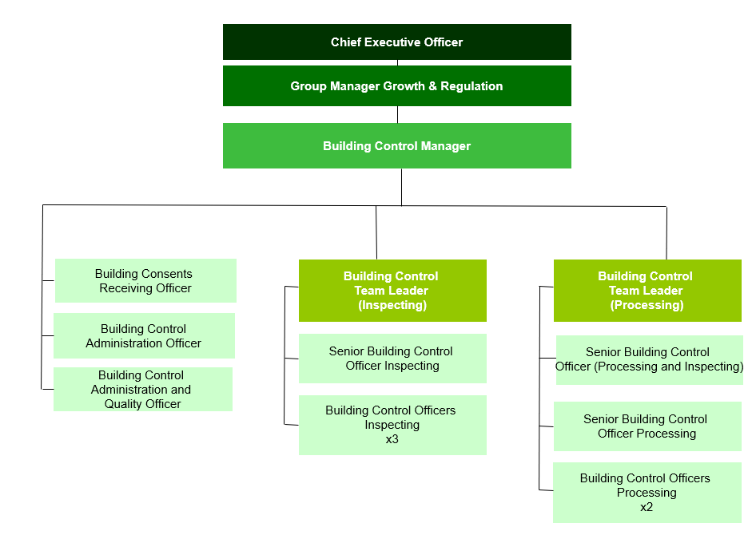

Our Vision: Making a difference


We as a Council strive to make a difference in our community in everything we do. In our work, in our district, and in our staff culture.

Making a difference means doing your job to the best of your ability, to improve the district, the towns we live in, and the lives of the people who live in Matamata-Piako.

The way we do things, has a real opportunity to make a difference in the lives of those who live in our communities.

Our Mission: Working with the community

Our mission is to work with the community to enhance the lives of all those in the district.

What we do has a direct effect on our community - the better the quality of our work and the more we work with our community, the better our community will be.

What we do matters.


Our Values: We do it right, we do it better, we do it together

Expected behaviours
We do it right
- We are accountable for our actions
- We take ownership of our work
- We provide great customer service
- We are professional in all our dealings with others
- We are aware of how our actions reflect on Council
- We are open and honest with each other
- We are trustworthy
- We are responsible for our own wellbeing and the wellbeing of our workmates

We do it better
- We are open to learning and change
- We are self motivated and we use our initiative
- We learn from our mistakes
- We challenge the status quo
- We strive for continuous improvement
- We are friendly, helpful and flexible
- We are solution centred

We do it together
- We work together as one team
- We respect and accept the views of others
- We are informed and we keep others informed
- We share our knowledge with other teams
- We celebrate success
- We are actively involved as part of the team

Key accountabilities

The position of Building Control Officer (Processing) encompasses the following functions or Key Accountabilities:

- Building Consent Processing
- Accrediation and Continuous Improvement
- Interdepartmental and Customer Relations
- Cover and Support
- Customer and Community Focus
- Corporate/Organisation Contribution

The requirements in the above Key Accountabilities are broadly identified below:

Jobholder is accountable for | Jobholder is successful when
- Building Consent Processing  - Processing Building Consents: Process Building Act applications in accordance with competency and level (including and not limited minor variations and amendments) in accordance with all aspects of the New Zealand Building Code, relevant legislation, and Council's Quality Management System (QMS).  - Granting of building consents: Building Consents that have been processed by the processing officer are to be granted in accordance with the Building Consent Authority’s QMS.  - Granting of building consents that have been recommended to be granted by external contractors.  - Quality of building consents recommended for granting, including but not limited to Form 5, and building consent documentation, is assessed to ensure that a high level of building consent is maintained.  - Compliance and Documentation: Record all reasons for decisions made on Objective Build and process sheets.  - Collaborating with Council Teams: Actively seek and incorporate feedback from other Council teams, such as planning and engineering. | - Building consents are processed accurately, within legislative and QMS requirements, and within the prescribed timeframes.  - Building consents are granted in compliance with the Building Consent Authority’s QMS system.  - All decisions are thoroughly documented, ensuring transparency and accountability.  - Building consents recommended to be granted by external contractors are granted without delay and within statutory timeframes.  - Any quality issues with building consents recommended to be granted by contractors are raised appropriately.  - Effective collaboration and communication with other departments are demonstrated, ensuring alignment and mutual support.
- Accrediation/Compentency and Continuous Improvement  - Maintaining Individual Competency: Complete and maintain competency as a Building Consent Processor to the required standard.  - Assisting with BCA Accreditation: Actively assist and contribute to the Building Team in maintaining and advancing their IANZ accreditation. Participate in accreditation processes, audits, and continuous improvement initiatives.  - Team Improvement Participation: Actively participate and contribute to the continuous improvement of the processing team and the Building Team as a whole.  - Knowledge Sharing: Bring back and share knowledge gained from courses and training with the team. | - Competency is achieved and actively maintained without lapses, meeting all required standards and criteria, with the jobholder taking ownership of maintaining their own competency.  - Contribute to the Building Team successfully maintaining and advances their IANZ accreditation, meeting all required standards and criteria.  - Regular contributions to team improvement initiatives are made, resulting in enhanced processes and team performance.  - Knowledge from courses and training is effectively shared with the team, leading to improved practices and professional development.
- Interdepartmental and Customer Relations  - Technical and Timely Information: Deliver accurate and timely technical information to customers (internal and external) in line with competency.  - Collaborating across Council: Work effectively with other Council teams to ensure a unified "One Council" approach.  - Duty Building Officer Availability: Be available as the duty building officer to assist with inquiries and provide support.  - LIM Report Assistance: Assist with providing comments and technical advice for Land Information Memorandum (LIM) reports. | - Customers (internal and external) receive clear, accurate, and timely technical information, enhancing their experience and satisfaction.  - Collaboration with other Council teams is seamless, promoting consistency and a unified approach across departments.  - Availability as the duty building officer is maintained, ensuring prompt assistance and support for inquiries.  - Comments for LIM reports are provided accurately and within the required timeframes, contributing to comprehensive and reliable reports.
- Cover and support  - Provide proactive cover and support within the Building Team, taking ownership of tasks and projects as directed by the Building Control Team Leader (Processing) and Building Control Manager, ensuring continuity and efficiency of the building function and Council services. | - Cover and support is provided as required.
- Customer and Community Focus  - To ensure that the reputation of Council is enhanced and that a sound relationship with the district community is developed by maintaining an open policy for community participation and the distribution of information.  - Ensure customers receive good service over the phone, face to face and through mail and email.  - Follow through on Customer Request for Service (CRM)  - To ensure cultural perspectives are reflected in all business practices. | - Agreed processes are used to enable a pro-active and positive Council interface with customers.  - Availability and readiness to meet and consult with individuals and community groups.  - Respond to customers in a timely manner and inform them of progress. No customer complaints received  - CRM and TRIM response times are met.  Evidence of cultural perspectives in consultation, with improved relationships and appropriate protocols observed.
- Corporate/Organisation Contribution  - To utilise, maintain and access council information systems ensuring data is current, accurate and available  - To maintain the security of the information systems and their content, and to follow policy with regard to the handling of information both electronic and physical.  - Comply with all Council’s policies and rules  - Work practices to reflect the corporate vision values and expectations  - Demonstrate a willingness to participate in special projects.  - Foster co-operation between other teams for the benefit of the organisation  - Participate in the development, implementation and continual improvement of procedures and standards, to ensure the provision of quality services to both internal and external customers  - Assist Councils emergency management response in the event of a civil defence declaration.  - Ensure that all Health and Safety requirements as outlined in the Health and Safety policy are complied with. | - That processes associated with information collection, recording, communication and maintenance are followed using the relevant procedures and standards, and following the requirements of the associated policies  - That there are no unauthorised breaches of the IT and Records Policies  - Complies with all policies and rules  - Promote and express pride in your team and the organisation.  - Participate, express ideas and viewpoints at team group meetings.  - Contribute to corporate initiatives when required.  - ISO 9001 quality management systems in PROMAPP are continually improved and maintained.  - Assist in Council’s emergency response actions as required.  - Ensure awareness of Health and Safety requirements and procedures.

Note
The above performance standards are provided as a guide only. The precise performance measures for this position will need further discussion between the jobholder and manager as part of the performance management process.

Work complexity
Most challenging duties typically undertaken:
- Processing Building Consents: Efficiently process building consent applications in accordance with the New Zealand Building Code, relevant legislation, and Council's Quality Management System (QMS).
- Providing Technical Advice: Offer clear and accurate technical advice in line with competency to both internal staff and external customers inline with compentency. Ensure that all parties are well-informed and supported, fostering a collaborative and knowledgeable environment.
- Customer Interaction: Manage interactions with customers, utilizing string communication skills to relay information and advice in a positive and factual manner. During challenging conversations, employ these skills to achieve desired outcomes while maintaining professionalism and fostering positive relationships.
- Maintaining Accreditation: Contribute towards Council continuing to meet its Building Control Accreditation requirements. Take ownership of maintaining personal competency, actively participating in continuous professional development and adhering to required standards.
- Interdepartmental Collaboration: Actively collaborate with other Council teams to ensure a unified "One Council" approach. Seek and incorporate feedback from departments such as planning and engineering to ensure building consents meet Council outcomes and policies while maintaining the BCA function.

Key relationship skills
Key internal and/or external contacts | Nature of the contact most typical  (e.g. courtesy, giving/receiving information, explaining things, liaising, advising, gaining cooperation, facilitating, influencing and persuading, resolving minor conflicts, mediating, negotiating, formal negotiation, supervising, leading.) | Frequency of interaction  D - daily  W - weekly  M - monthly
Building Control Manager / Team Leader | Courtesy, giving/receiving information, explaining things, liaising, advising | D
Building Team | Courtesy, giving/receiving information, explaining things, liaising, advising | D
Internal Council Teams e.g. Planning, Customer Services | Courtesy, giving/receiving information, explaining things, liaising, advising, gaining cooperation | D
External consultants | Courtesy, giving/receiving information, explaining things, liaising, advising, gaining cooperation, | D
Public | Courtesy, giving/receiving information, explaining things, liaising, advising, gaining cooperation, influencing and persuading | D
IANZ | Courtesy, giving/receiving information, explaining things, liaising, advising | Y

Examples of the situations which require the use of the highest level of communication or influencing skills:

- Resolving Conflicts: Address conflicts where external parties may have different views on the legislation compared to Council's interpretation. Navigate these differences as effectively as possible while ensuring compliance with legislative requirements, negotiating mutually acceptable outcomes.
- Explaining Building Controls: Communicate the necessity of building controls or specific information to customers who may perceive these requirements as bureaucratic. Use strong communication and influencing skills to convey the importance of these controls in a positive and factual manner, helping customers understand their value and necessity.

Examples where the role co-ordinates or provides coaching or monitors the work of other people not reporting directly to the role (e.g. contractors)?
- Interdepartmental Coordination: Collaborate with Engineering and Planning staff to ensure building consents are coordinated to include input from the entire Council.

Person specification
This section is designed to capture the expertise required for the role at the 100% fully effective level. (This does not necessarily reflect what the current jobholder has.) This may be a combination of qualifications/experience, knowledge or equivalent level of learning through experience or key skills, attributes or job specific competencies.
Essential | Preferred
Education and qualifications•  - A qualification in accordance with Regulation 18 of the Building Act – i.e. Degree or Diploma in relevant field (i.e. Bachelors of Technology – Building; Architecture; Architectural Studies; Building Science; Construction, Engineering or Diplomas of Building Control Surveying) or currently working towards one.  - Current NCAS Competency Assessment Residential 1  Knowledge and experience  - Understanding of the Building Act, Code and associated Regulations  - Full drivers Licence | Education and qualifications  - Current NCAS Competency Residential 1 or 2  Knowledge and experience  - Previous experience in a Building Consent Authority  - Experience in the building industry  - Experience using Objective Build
Skills & Competencies

- Report Writing - Expressing ideas clearly in reports or other documents that have appropriate organisation and structure, correct grammar, language and terminology, adjusted to the characteristics and needs of the audience.
- Excellent computer skills especially in Word and Excel
- Customer Focus - Makes customers & their needs a primary focus of their actions. Develops and sustains productive customer relationships. Understands customer service principles & practices. Presents a professional image, eg.dress code, behaviour, conduct
- Teamwork - Actively participates as a member of a team. Contributes actively and fully to team projects by working with colleages collaboratively, working towards consensual solutions that enhance the output of the team. Accepts share of workload.
- Relationship management – Establishes and maintains business relationships both internal and external.
- Communication - Clearly conveys information and ideas through a variety of appropriate media to individuals or groups in a manner that helps them understand and retain the message. Communicates in a compelling and articulate manner that instills commitment
- Demonstrates strong ability to plan, prioritise, and manage workload to meet deadlines while maintaining quality and adapting to changing demands.

Change to position description
From time to time it may be necessary to consider changes in the position description in response to the changing nature of our work environment – including technological requirements or statutory changes. This position description may be reviewed as part of the preparation for performance planning for the annual performance cycle or as required.

Position holder Date

