Position Description

Title | Kaiwhakahaere marumaru | Emergency Management Officer South Waikato District Council
Group: | Group Manager Growth & Regulation
Reports to: | Emergency Management Manager
Number of staff reporting to this position | No Direct Reports
Shared Service | The delivery of Civil Defence and Emergency Management (CDEM) is delivered through a shared service arrangement (SSA) between the Hauraki, Matamata-Piako and South Waikato District Councils. This SSA has been established to plan for, coordinate and deliver emergency management civil defence services across the three local Council areas. Matamata-Piako District Council is the administering authority however this position’s CDEM focus is for South Waikato District Council
Position purpose: | This positions key purpose is to deliver the following:  - Support the delivery of CDEM by collaborating with and supporting iwi/Māori, communities and agencies to understand their hazards, plan for and develop preparedness and collectively build resilience against disasters.  - Deliver work programmes based on local priorities and align these with the Waikato CDEM Plan, engaging with the subject matter expertise of the wider Waikato CDEM team’s professional staff.  - Coordinate CDEM plans and procedures, as rehearsed, and rapidly respond to the unfolding needs of an emergency
Position Grade | 14
Date: | May 2026

Organisation context

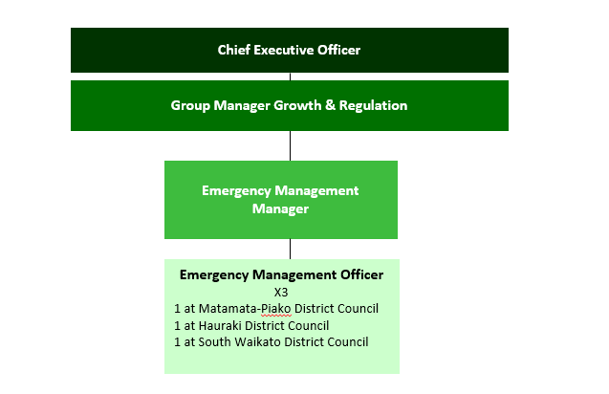

Our Vision: Making a difference

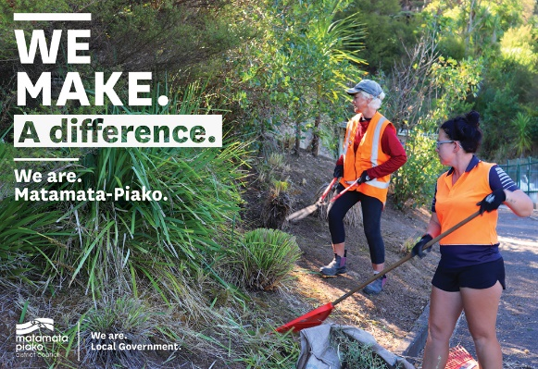
We as a Council strive to make a difference in our community in everything we do. In our work, in our district, and in our staff culture.

Making a difference means doing your job to the best of your ability, to improve the district, the towns we live in, and the lives of the people who live in Matamata-Piako.

The way we do things, has a real opportunity to make a difference in the lives of those who live in our communities.

Our Mission: Working with the community
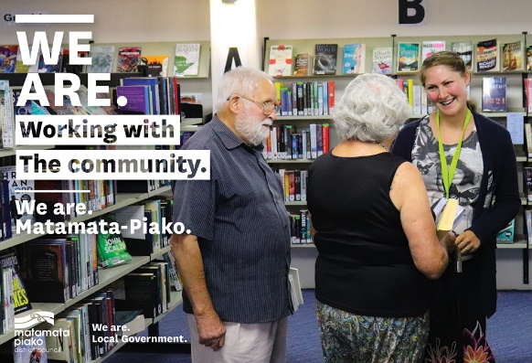
Our mission is to work with the community to enhance the lives of all those in the district.

What we do has a direct effect on our community - the better the quality of our work and the more we work with our community, the better our community will be.

What we do matters.

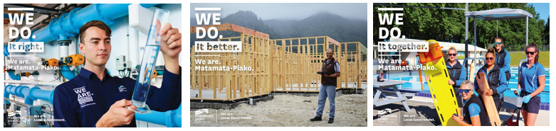
Our Values: We do it right, we do it better, we do it together

Expected behaviours
We do it right
- We are accountable for our actions
- We take ownership of our work
- We provide great customer service
- We are professional in all our dealings with others
- We are aware of how our actions reflect on Council
- We are open and honest with each other
- We are trustworthy
- We are responsible for our own wellbeing and the wellbeing of our workmates

We do it better
- We are open to learning and change
- We are self motivated and we use our initiative
- We learn from our mistakes
- We challenge the status quo
- We strive for continuous improvement
- We are friendly, helpful and flexible
- We are solution centred

We do it together
- We work together as one team
- We respect and accept the views of others
- We are informed and we keep others informed
- We share our knowledge with other teams
- We celebrate success
- We are actively involved as part of the team

Key accountabilities

The position of Emergency Management Officer encompasses the following functions or Key Accountabilities:

- CDEM (Civil Defence Emergency Management) Operations
- Stakeholder and Partner Engagement
- Capability Development
- Cover and support
- Customer and Community Focus
- Corporate/Organisation Contribution

The requirements in the above Key Accountabilities are broadly identified below:

Jobholder is accountable for | Jobholder is successful when
- CDEM Operations  - Research and create standard operating procedures from CDEM in conjunction with Emergency Management Manager to maintain readiness.  - Regularly review and refresh standard operating procedures (SOPs) for all operational activities across all aspects of emergency management (EM) within the member Councils.  - Coordinate and deliver training requirements for response operations for Matamata-Piako District Council.  - Assist participating controllers in emergencies to ensure emergencies are managed in accordance with the scale of the activity, existing plans and SOPs.  - Assist in the implementation and review of plans and systems.  - Support and assist the Controller, Recovery Manager, Response Manager and Function Managers and teams.  - Act as Duty Officer on the Eastern Waikato Duty Roster as required.  - Schedule, book and coordinate all training sessions and meetings for CDEM and associated requirements (i.e. venue, diary management)  - Ensure EOC and CDC electronic systems and databases are updated regularly.  - Update CDEM information on the Council’s internal and external websites.  - Produce CDEM reports as when and as requested by the manager i.e Council reports, Group reports etc..  - Monitor and proactively promote CDEM promotions and activities.  - Identify and implement social marketing tools for use during an emergency.  - Manage EOC and CDC electronic resources  - Demonstrate a strong and genuine commitment to Te Tiriti o Waitangi by actively upholding its principles through respectful partnership with mana whenua, recognising Māori as tangata whenua, and supporting Māori participation in decision-making. | - SOPs and plans are developed and implemented and are aligned with Waikato Group CDEM guidelines.  - Training requirements are coordinated to maintain a state of operational readiness of Council’s CDEM response.  - Actively supports the controller and or response manager to ensure emergencies are managed in accordance with the scale of the activity, existing plans and SOPs.  - Led implementation and review of plans and systems.  - Support is provided to the Controller, Recovery Manager, Response Manager and Function Managers.  - Roster is completed as scheduled for the Eastern Waikato.  - Meetings and training course scheduled and coordinated in a timely professional manner.  - EOC and CDC databases are up to date and accurate.  - Websites regularly updated with CDEM content.  - Accurate reports produced in a timely manner.  - CDEM promotions actively supported by each Council.  - Opportunities for use of social marketing tools are identified and used as required.  - EOC and CDC electronic resources are managed appropriately.  - Effective partnerships with mana whenua that uphold Te Tiriti and embed mātauranga Māori into emergency management practice, and deliver inclusive, culturally appropriate CDEM outcomes.
- Partnerships and Stakeholder Engagement  - Develop and maintain effective partnerships with iwi/Māori Emergency Services, Lifeline Utilities, Central Government Agencies, Community Organisations, and the Private Sector to strengthen Civil Defence Emergency Management capability across risk reduction, readiness, response, and recovery.  - Support local communities, whanau,hapu, iwi and stakeholders in delivering projects such as public education, neighbourhood response plans and capability development mapping and delivery.  - Work with Emergency Management Manager to identify the hazards of local communities that may be vulnerable to hazards and develop a targeted and prioritised local response programme.  - Engage and liaise with the Waikato CDEM Group Office (GEMO) and key stakeholders, with particular regard for the coordination and implementation of CDEM planning and operations process.  - Develop and promote opportunities to raise awareness of key CDEM messages.  - Develop and deliver campaigns to raise CDEM awareness within the community about local risks, and the importance of emergency preparedness are maximised. | - Trusted, active partnerships that are clearly defined, regularly engaged, and demonstrably improving the council’s ability to reduce risk, be ready, respond effectively, and support community recovery during emergencies.  - Whanau, hapu, iwi and Local stakeholders are informed and engaged early in the process engendering buy-in and ownership in readiness and response planning process.  - Local communities and organisations are supported in the development and on-going maintenance of plans.  - Community response planning, public education and stakeholder engagement is targeted based on priority as agreed and directed by the Emergency Management Manager (i.e. most vulnerable to least vulnerable).  - Emergency Management Manager is supported with the coordination of the Waikato CDEM Group Office (GEMO) planning and operations process i.e. planning, assessment and drafting of strategies related to the Waikato GEMO.  - Public education events co-ordinated to meet organisational objectives.  - Campaigns are designed and delivered to raise CDEM awareness within the community about local risks, and the importance of emergency preparedness are maximised
- Capability Development  - Design and deliver local training to staff, community (e.g. volunteers and stakeholders e.g. iwi Māori.  - Maintain operational training records in conjunction with relevant team (People, Safety and Wellness team) and in accordance with the Council’s processes and procedures.  - Monitor and evaluate the outcomes of exercises and training, and how it has enhanced CDEM operational capability.  - Prepare training documentation and associated materials required for training sessions.  - Make appropriate choices in the use of technology to produce and adapt learning materials. | - Training plans and programmes are prepared and delivered to meet local training needs and fill identified gaps or capability development options.  - Training quality and relevance is regularly evaluated to ensure they fulfil needs.  - Staff, community and stakeholders receive the most appropriate and timely training.  - Accurate training records are maintained and are readily available.  - Robust training documentation prepared.  - Coordinate and support volunteers to actively contribute to community resilience and emergency response activities.
- Cover and support  - To provide cover and support within the team as directed by your manager | - Cover and support is provided as required.
- Customer and Community Focus  - To ensure that the reputation of Council is enhanced and that a sound relationship with the district community is developed by maintaining an open policy for community participation and the distribution of information.  - Ensure customers receive good service over the phone, face to face and through mail and email.  - Follow through on Customer Request for Service (CRM)  - To ensure cultural perspectives are reflected in all business practices. | - Agreed processes are used to enable a pro-active and positive Council interface with customers.  - Availability and readiness to meet and consult with individuals and community groups.  - Respond to customers in a timely manner and inform them of progress. No valid complaints received.  - CRM and CM response times are met.  - Evidence of cultural perspectives in consultation, with improved relationships and appropriate protocols observed.
- Corporate/Organisation Contribution  - To utilise, maintain and access council information systems ensuring data is current, accurate and available.  - To maintain the security of the information systems and their content, and to follow policy with regard to the handling of information both electronic and physical.  - Comply with all Council’s policies and rules.  - Work practices to reflect the corporate vision values and expectations.  - Demonstrate a willingness to participate in special projects.  - Foster co-operation between other teams for the benefit of the organisation.  - Participate in the development, implementation and continual improvement of procedures and standards, to ensure the provision of quality services to both internal and external customers.  - Assist Councils emergency management response in the event of a civil defence declaration.  - Ensure that all Health and Safety requirements as outlined in the Health and Safety policy are complied with. | - That processes associated with information collection, recording, communication and maintenance are followed using the relevant procedures and standards, and following the requirements of the associated policies.  - That there are no unauthorised breaches of the IT and Records Policies.  - Complies with all policies and rules.  - Promote and express pride in your team and the organisation.  - Participate, express ideas and viewpoints at team group meetings.  - Contribute to corporate initiatives when required.  - The quality management system is continually improved and maintained.  - Assist in Council’s emergency response actions as required.  - Ensure awareness of Health and Safety requirements and procedures.

Note
The above performance standards are provided as a guide only. The precise performance measures for this position will need further discussion between the jobholder and manager as part of the performance management process.

Emergency Response
In the event of a civil defence or other emergency event in the South Waikato District or Waikato Region, the South Waikato EMO will be required to assist in the response. This may involve work in the South Waikato Emergency Operations Centre (EOC) or, where required and requested, at another centre in support of a national or neighbouring regional event.
This may include potentially long hours and difficult working conditions, e.g. an emergency event could occur at any time of the day or night and may require working shifts and/or working weekends. As much as possible will be done to support staff in meeting their family responsibilities during an emergency.

Work complexity
Most challenging duties typically undertaken:
- The role requires the EMO to find innovative ways to engage with individuals, communities and organisations in order to build community resilience.
- The role requires influencing local South Waikato District Council staff to engage in CDEM planning and activities.
- The role includes fostering and sustaining effective relationships with a broad number of sector stakeholders.
- Balancing immediate and short-notice tasks with medium to long-term priorities.

Key relationship skills

Key internal and/or external contacts | Nature of the contact most typical  (e.g. courtesy, giving/receiving information, explaining things, liaising, advising, gaining cooperation, facilitating, influencing and persuading, resolving minor conflicts, mediating, negotiating, formal negotiation, supervising, leading.) | Frequency of interaction  D - daily  W - weekly  M - monthly
Public (including community and volunteer groups) | Courtesy, giving/receiving information, explaining things, liaising, advising, gaining cooperation, facilitating, influencing and persuading | D
MPDC Staff | Courtesy, giving/receiving information, explaining things, liaising, advising, gaining cooperation, facilitating, influencing and persuading | D
Councillors | Courtesy, giving/receiving information, explaining things, liaising, advising, gaining cooperation, facilitating. | M
Iwi / Māori | Courtesy, giving/receiving information, explaining things, liaising, advising, gaining cooperation, facilitating, influencing and persuading | W
Emergency Services and Government Agencies | Courtesy, giving/receiving information, explaining things, liaising, advising, gaining cooperation, facilitating, influencing and persuading | W
EM Professionals | Courtesy, giving/receiving information, explaining things, liaising, advising, gaining cooperation, influencing and persuading | D

Examples of the situations which require the use of the highest level of communication or influencing skills:
- Co-ordinating and providing advice during an CDEM emergency
- Engaging with the community to build community resilience
- The role requires influencing South Waikato District Council staff to engage in CDEM planning and activities

Examples where the role co-ordinates or provides coaching or monitors the work of other people not reporting directly to the role (e.g. contractors)? Two examples, how often?
- Co-ordinating and providing advice during an CDEM emergency

Person specification
This section is designed to capture the expertise required for the role at the 100% fully effective level. (This does not necessarily reflect what the current jobholder has.) This may be a combination of qualifications/experience, knowledge or equivalent level of learning through experience or key skills, attributes or job specific competencies.

Essential | Preferred
Education and qualifications  - Tertiary degree or equivalent experience in emergency management or similar role  - CIMS 2 & CIMS4  - Full NZ Drivers Licence |  | - Emergency Management Diploma / Certificate  - Integrated Training Framework (ITF)  - ITF Foundational  - ITF Intermediate  - ITF Logistics  - ITF Welfare  - ITF Civil Defence Centre Supervisor  - Leadership and or equivalent coordination centre training  - Response Driving experience  - IAP2 (Public Participation Training)
Knowledge and experience  - Two years CDEM experience or two years in a similar role.  - High level of knowledge of MS Office applications (i.e. Word, Outlook, and Excel) and internet explorer.  - Good understanding of CDEM principles  - Working knowledge of local government legislation and policies.  - Good customer service skills and ethic |  | - Extensive knowledge of the local government sector  - Knowledge of project management principles and methodology

Skills & Competencies

- Adaptability - Understanding and appreciating different and opposing perspectives on issues: adapting an approach as the requirements of the situation change.

- Collaboration - Working effectively with others in the organisation outside the line of formal authority (such as peers in other units or senior management) to accomplish organisational goals.

- Interpersonal Skills - Establishing and maintaining relationships with staff, customers and suppliers to improve the overall effectiveness of the position

- Community Awareness - Considers impact of proposed actions/decisions on local community; develops relationships with, consults with and involves community in areas of interest/impact.

- Decisionmaking / Problem Solving - Is able to analyse and solve complex problems, form judgements and make decisions within known parameters. Can resolve conflict or differences of opinion.

- Organisation Skills - Has a systematic approach that leads to the successful completion of tasks and events. Has ability to programme and organise work, and keeps functional records and filing systems in order.

Change to position description
From time to time it may be necessary to consider changes in the position description in response to the changing nature of our work environment – including technological requirements or statutory changes. This position description may be reviewed as part of the preparation for performance planning for the annual performance cycle or as required.

Position holder Date

