Position Description

Title | Solid Waste Lead
Group: | Infrastructure Assets and Operations
Reports to: | Infrastructure Asset and Strategy Team Leader
Number of staff reporting to this position: | No Direct Reports
Position purpose: | The Solid Waste Lead role leads the management of the solid waste activity at a strategic and technical level, including the provision of advice, oversight and management of waste minimisation, solid waste asset management planning, refuse transfer stations, and closed landfill assets and obligations. This includes asset management plan development and maintenance, project management, recycling and resource recovery initiatives, growth planning support, compliance oversight, and the planning and improvement of solid waste facilities and services.  This role is also responsible for the management and allocation of waste levy funds, grant funding and associated financial reporting, including Ministry for the Environment funding, milestone reporting, and ensuring statutory, consent and governance requirements are met. The role maintains key relationships with regulators, industry bodies, territorial authorities, contractors, consultants, community groups and grant recipients to support effective delivery of Council’s solid waste objectives.
Position Grade | 17
Date: | March 2024

Organisation context

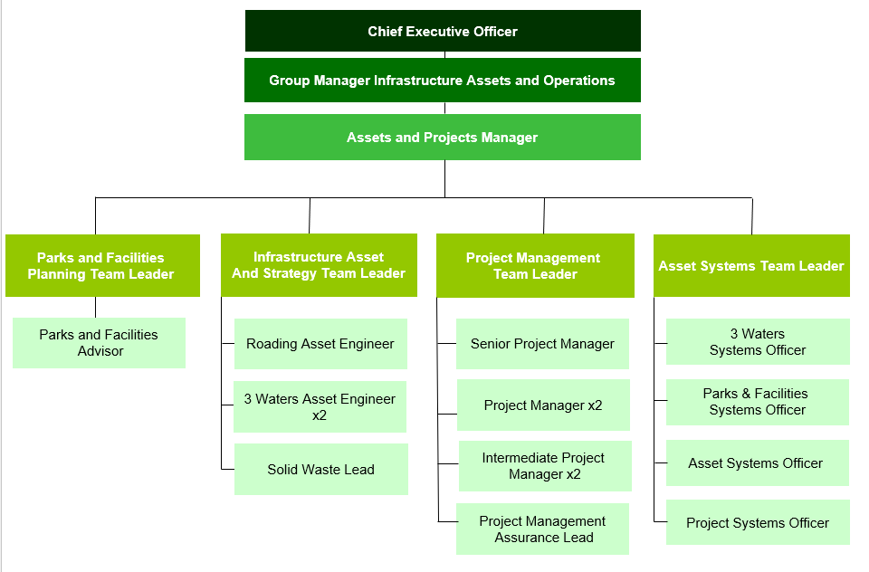

Our Vision: Making a difference

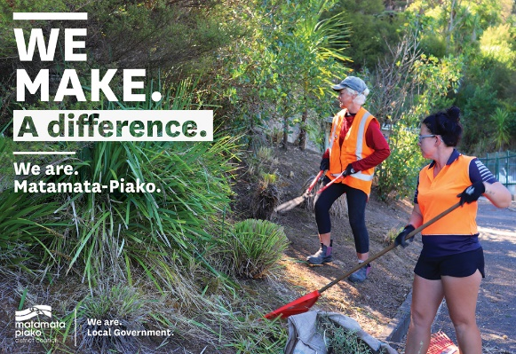
We as a Council strive to make a difference in our community in everything we do. In our work, in our district, and in our staff culture.

Making a difference means doing your job to the best of your ability, to improve the district, the towns we live in, and the lives of the people who live in Matamata-Piako.

The way we do things, has a real opportunity to make a difference in the lives of those who live in our communities.

Our Mission: Working with the community
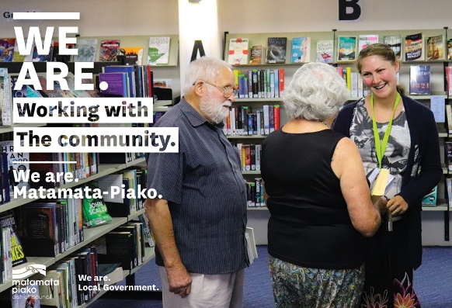
Our mission is to work with the community to enhance the lives of all those in the district.

What we do has a direct effect on our community - the better the quality of our work and the more we work with our community, the better our community will be.

What we do matters.

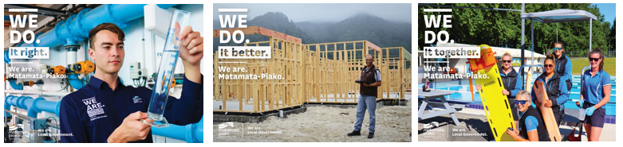
Our Values: We do it right, we do it better, we do it together

Expected behaviours
We do it right
- We are accountable for our actions
- We take ownership of our work
- We provide great customer service
- We are professional in all our dealings with others
- We are aware of how our actions reflect on Council
- We are open and honest with each other
- We are trustworthy
- We are responsible for our own wellbeing and the wellbeing of our workmates
- We are approachable, direct, open and honest when communicating with others
- We lead by example and demonstrate our vision and values in all that we do
We do it better
- We are open to learning and change
- We are self motivated and we use our initiative
- We learn from our mistakes
- We challenge the status quo
- We strive for continuous improvement
- We are friendly, helpful and flexible
- We are solution centred
- We enable and trust our team to make decisions, display initiative and take risks
- We actively encourage our team to broaden their skills and reach their full potential
We do it together
- We work together as one team
- We respect and accept the views of others
- We are informed and we keep others informed
- We share our knowledge with other teams
- We celebrate success
- We are actively involved as part of the team
- We are clear on where our team is heading and what we need to achieve
- We use delegation as an effective management tool
- We actively encourage working together and respecting other teams

Key accountabilities

The position of Solid Waste Lead encompasses the following functions or Key Accountabilities:

- Technical and Strategic Advice
- Asset Planning and Solid Waste Infrastructure Management
- Relationship Management
- Financial Management of Waste Levy Funds and Grants
- Customer and Community Focus
- Corporate/Organisation Contribution

The requirements in the above Key Accountabilities are broadly identified below:

Jobholder is accountable for | Jobholder is successful when
- Technical and Strategic Advice  - Provide technical advice and support to the Team Leader, elected members and staff on solid waste management matters as appropriate.  - Provide advice to staff on legislative, policy and consent issues in relation to waste management, including upcoming legislative changes and recommended responses.  - Support Council decision-making by providing clear analysis, recommendations and information on strategic solid waste issues.  - Provide strategic advice and recommendations on Council’s key solid waste services, including kerbside collection services, service levels, service delivery options, contract models and future service changes.  - Contribute to regional and inter-regional initiatives and provide feedback and recommendations to management as required. |  | - Management, elected members and staff are kept informed on solid waste issues relevant to their responsibilities.  - Advice provided is timely, accurate, practical and supports informed decision-making.  - Legislative, policy and consent implications are clearly identified and communicated to relevant stakeholders.  - Relevant sector participation, feedback and recommendations are provided to management in a timely manner.
- Asset Planning and Solid Waste Infrastructure Management  - Lead the development, maintenance and continuous improvement of the Solid Waste Asset Management Plan and related asset planning documents for solid waste infrastructure and closed landfill assets.  - Manage closed landfill lifecycle planning, including aftercare, capping, condition assessment, renewal planning, consent management, consent renewals or replacement processes before expiry, risk assessment and consent compliance obligations.  - Coordinate environmental monitoring requirements for closed landfills, including leachate, groundwater and landfill gas monitoring, and ensure information is available for reporting and compliance purposes.  - Commission and oversee the Solid Waste Analysis Protocol survey, review waste assessments, and lead development of the Waste Management and Minimisation Plan, including community consultation and statutory processes.  - Plan and support refuse transfer station upgrades, enhancements and future service options, including project scoping, concept development, CAPEX and OPEX planning, and coordination with internal and external partners.  - Provide input into LTP, Annual Plan, fees and charges, growth planning, capital business cases and service planning for solid waste infrastructure and services.  - Lead updates to the Solid Waste Bylaw and support integration of extended producer responsibility schemes and emerging waste streams into Council services and facilities where appropriate.  - Maintain solid waste asset data, utilisation, condition and performance information, and support systems and process improvements for planning, reporting and decision-making.  - Manage contractors and consultants engaged for investigations, studies, renewals, monitoring, consent renewals and improvement programmes relating to solid waste assets and services. |  | - The Solid Waste Asset Management Plan and related planning documents are current, fit for purpose and aligned to Council planning and investment requirements.  - Closed landfill assets are managed proactively, with lifecycle needs, aftercare requirements, renewals, consent renewals or replacements before expiry, risks and consent obligations identified and addressed.  - Environmental monitoring, compliance information and consent reporting for closed landfills are completed accurately and on time.  - The WMMP is supported by current waste data, statutory requirements are met, consultation processes are completed appropriately, and Council is well positioned for adoption and implementation.  - Refuse transfer stations are safe, compliant, fit for purpose and progressively improved to support waste minimisation, operational efficiency and future growth.  - CAPEX, OPEX, fees and charges, growth planning inputs and business cases are evidence-based, timely and support sound decision-making.  - The Solid Waste Bylaw, EPR-related service responses and other planning documents are updated as required by legislation, policy or service needs.  - Asset, utilisation and performance data are accurate, available and used effectively for reporting, analysis and service improvement.  - Consultants and contractors deliver agreed outputs, monitoring, investigations and improvement works to the required standard and within approved timeframes and budgets.
- Relationship Management  - Customers, contractors, stakeholders and staff are supported with professional, accurate and timely advice and guidance on relevant legislation, consent conditions, waste minimisation initiatives and solid waste service matters as required.  - Maintain effective working relationships with the Ministry for the Environment, WasteMINZ, territorial authorities, regional forums, community groups, grant recipients, consultants, contractors and other stakeholders relevant to the solid waste activity.  - Represent Council in regional and inter-regional initiatives, sector discussions and collaborative opportunities to support policy alignment, funding opportunities, service improvement and shared learning.  - Identify and support collaboration opportunities across the district and region, including funding initiatives, spoke-and-hub approaches and other partnership models that improve waste minimisation outcomes and value for money.  - Work with brand owners, service providers and other parties as extended producer responsibility schemes and other product stewardship initiatives are introduced or expanded. | - Effective working relationships are established and maintained with customers, contractors, stakeholders, staff, elected members, government agencies, industry organisations and community groups.  - Internal and external stakeholders are well informed, consulted appropriately and engaged constructively in Council decision-making and service planning.  - Council is represented effectively in regional and inter-regional solid waste initiatives, and relevant opportunities, risks and recommendations are communicated promptly to management.  - Collaborative opportunities support improved service outcomes, alignment with sector expectations and access to appropriate external funding opportunities.  - Waste projects, service responses and facility planning are informed by current sector relationships, stewardship developments and Ministry for the Environment expectations.
- Financial Management of Waste Levy Funds and Grants  - Manage the waste levy funds received from the Ministry for the Environment, including allocation of funding in line with the Waste Management and Minimisation Plan and relevant internal approvals.  - Administer grant funding and deed obligations, including contestable funding applications, milestone reporting, expenditure tracking, record keeping, audits and formal close-out requirements.  - Prepare, advertise and manage contestable grants and funding rounds for waste minimisation initiatives, including assessment support, recommendations, approvals and reporting back to elected members and management.  - Provide robust financial and programme reporting for levy funds, grants and related projects, including reporting to Ministry systems and internal governance requirements. | - Funds are allocated, administered and reported in accordance with Ministry for the Environment guidelines, deed requirements and Council approvals.  - Milestone reports, expenditure records, audit information and close-out documentation are complete, accurate and submitted on time.  - Contestable grants and levy-funded initiatives are managed transparently, with appropriate governance, documentation and reporting to elected members and management.  - Financial records and programme reporting support compliance, accountability and effective delivery of waste minimisation outcomes.
- Customer and Community Focus  - Maintain an open, responsive and professional approach to customer and community engagement so Council’s reputation is enhanced and constructive relationships are supported.  - Ensure customers receive good service by phone, email, written correspondence and in person.  - Respond to customer requests for service and community enquiries promptly, following through on actions and keeping people informed of progress where appropriate.  - Ensure cultural perspectives are respected and reflected appropriately in engagement, consultation and business practices. | - Agreed processes are used to support a proactive and positive Council interface with customers and the community.  - Customers and community groups are treated professionally, with information provided clearly and in a timely manner.  - Customer requests and correspondence are responded to within expected timeframes, with progress communicated appropriately.  - Engagement and consultation practices reflect appropriate cultural awareness, protocols and relationship-building.
- Corporate/Organisation Contribution  - Use, maintain and access Council information systems so data is current, accurate and available.  - Maintain the security of information systems and their content, and follow Council policy for handling information in electronic and physical form.  - Comply with all Council policies, procedures and rules.  - Ensure work practices reflect Council’s vision, values and behavioural expectations.  - Participate in special projects, continuous improvement activity and cross-team cooperation for the benefit of the organisation.  - Assist with Council’s emergency management response if required.  - Meet health and safety obligations and ensure compliance with relevant legislation. | - Information is recorded, maintained and communicated in accordance with relevant procedures, standards and policies.  - There are no unauthorised breaches of information management, records or IT policies.  - Council policies and rules are consistently complied with.  - The role contributes positively to team culture, corporate initiatives and organisational improvement.  - Quality, emergency management and health and safety requirements are understood and met.  - Relevant legislation is complied with in accordance with Council requirements.

Note
The above performance standards are provided as a guide only. The precise performance measures for this position will need further discussion between the jobholder and manager as part of the performance management process.

Work complexity

Most challenging duties typically undertaken:
- Evaluates waste minimisation projects, assessing viability for funding, prepares approvals, monitors outcomes and reports results.
- Negotiating with multiple parties and organisations to reach agreement for solutions that are put forward for funding; approved or declined.
- Milestone reporting and financial management of funds to meet critical reporting requirements and deadlines, both internal and external.
- Exercises good judgment in all activities utilising technical knowledge and expertise.

Key relationship skills

Key internal and/or external contacts | Nature of the contact most typical  (e.g. courtesy, giving/receiving information, explaining things, liaising, advising, gaining cooperation, facilitating, influencing and persuading, resolving minor conflicts, mediating, negotiating, formal negotiation, supervising, leading.) | Frequency of interaction  D - daily  W - weekly  M - monthly
Public | Courtesy, giving/receiving information, explaining things to people, clarifying needs | D
Staff | Giving and receiving information, explaining things to people | D
Managers | Liaising, giving receiving information | W
Consultants | Commissioning and reviewing reports, monitoring works and providing information | As required
Contractors/brand owners | Giving and receiving information, influencing, supervising new service options | As required
Community Groups | Courtesy, giving and receiving information, facilitating, influencing, persuading | As required

Examples of the situations which require the use of the highest level of communication or influencing skills:
- Communicating effectively with a wide range of parties from elected officials, senior management, contractors, community groups and individuals.
- Negotiating acceptable service levels and costs that are beneficial for all parties
- Maintaining good relationships with service providers/ consultants to ensure MPDC needs are met when they have competing offers in a sector that is under resourced
- Ensuring decisions that may be contentious are presented in a way to gain understanding and/or agreement

Examples where the role co-ordinates or provides coaching or monitors the work of other people not reporting directly to the role (e.g. contractors)? Two examples, how often?
- Customers, stakeholders, and staff are supported with professional, accurate and timely advice and guidance on the solid waste matters, relevant legislation, and consent conditions, as required.
- External relationships are professionally managed with clear communication on expectations
- Key stakeholders are well informed and consulted, with input and influence from Council in decision making.
- Mentoring Waste Minimisation Officer role (when established) to ensure both corporate and external processes and reporting are met
Person specification
This section is designed to capture the expertise required for the role at the 100% fully effective level. (This does not necessarily reflect what the current jobholder has.) This may be a combination of qualifications/experience, knowledge or equivalent level of learning through experience or key skills, attributes or job specific competencies.

Essential | Preferred
Education and qualifications  - Full New Zealand Driver Licence  - Sound understanding of the Waste Minimisation Act 2008, Local Government Act 2002, Resource Management Act requirements as they relate to closed landfills and solid waste activities, and relevant bylaws, consent and regulatory frameworks  - Understanding of government, statutory and funding reporting requirements relevant to solid waste activities  - Sound understanding of waste-related compliance requirements, including consent monitoring and reporting obligations | - A relevant tertiary qualification in environmental management, engineering, infrastructure planning, resource management, waste management or a related discipline is preferred  - Equivalent practical experience in solid waste management, waste minimisation, asset planning, contract management and project delivery may be considered  - At least five years’ experience in a similar or related role is preferred  - Strong decision-making and problem-solving skills, with the ability to analyse information, exercise judgement and take accountability for outcomes
Knowledge and experience  - Substantial experience in a related field.  - Knowledge of environmental, solid waste and waste minimisation issues, including current and emerging service delivery considerations  - Experience in asset planning, infrastructure planning and maintenance planning.  - Experience managing or supporting closed landfill obligations, environmental monitoring, consent compliance or similar regulatory requirements  - Ability to identify solutions, prepare sound recommendations and produce well-argued results  - Good written and oral communication skills  - Excellent computer, data management and time management skills | - Ability to contribute to strategic discussion and confidently influence decisions using well-developed interpersonal and communication skills  - Solution-focused approach, with an understanding of the importance of key relationships and a commitment to acting with honesty, transparency and professionalism  - Experience operating within legislative, bylaw, consent, funding and governance frameworks relevant to local government and solid waste activities  - Experience with stakeholder engagement, funding applications or grant administration is advantageous

Skills & Competencies
- Collaboration - Working effectively with others in the organisation outside the line of formal authority (such as peers in other units or senior management) to accomplish organisational goals.
- Conflict Management - Recognising conflict and bringing it out into the appropriate situation for resolution by applying effective conflict management approaches and techniques
- Consultation - applying appropriate consultative processes and procedures; summarising and disseminating the outcomes or consensus of the process
- Project Management - Planning and overseeing the achievement of a goal or objective within a certain timeframe by dividing it into a set of sequenced and inter-related actions or tasks, monitors and troubleshoots the achievement of tasks.
- Commitment/Personal Accountability - Is self motivating and self managing. Follows through projects to completion. Has high standards of personal integrity and professionalism.
- Decision making/Problem solving - Making timely decisions; judgements; taking action when appropriate and committing to a position or direction

Change to position description
From time to time it may be necessary to consider changes in the position description in response to the changing nature of our work environment – including technological requirements or statutory changes. This position description may be reviewed as part of the preparation for performance planning for the annual performance cycle or as required.

Position holder Date

