**Position Description**

|  |  |
| --- | --- |
| Title | Governance Advisor / Senior Governance Advisor |
| Group: | People, Governance & Relationships |
| Reports to: | Governance Team Leader |
| Number of staff reporting to this position | Nil |
| Position purpose: | Provides coordination and administrative functions Council and all Council Committees, including guidance, advice (particularly in regards to Standing Order and relevant legislation i.e. LGOIMA).  Assists with the coordination and administrative functions to all Council grant processes, including guidance, advice and support services.  Provide administrative functions to the wider Policy, Partnerships and Governance team where required, in particular key projects such as the Long Term Plan, Annual Plan, Annual Report, Policies, Bylaws, Local Election, Representative Reviews, and Community Development and Partnership initiatives. |
| Position Grade | 11 |
| Date: | July 2025 |

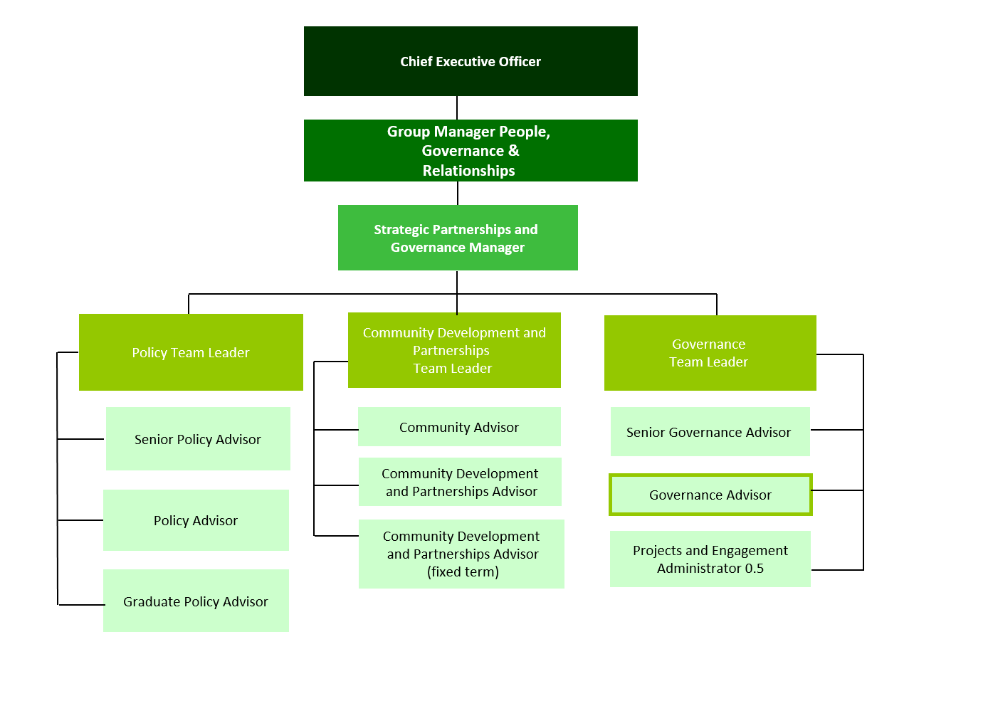**Organisation context**

**Our Vision: Making a difference**

We as a Council strive to make a difference in our community in everything we do. In our work, in our district, and in our staff culture.

Making a difference means doing your job to the best of your ability, to improve the district, the towns we live in, and the lives of the people who live in Matamata-Piako.

The way we do things, has a real opportunity to make a difference in the lives of those who live in our communities.

**Our Mission: Working with the community**

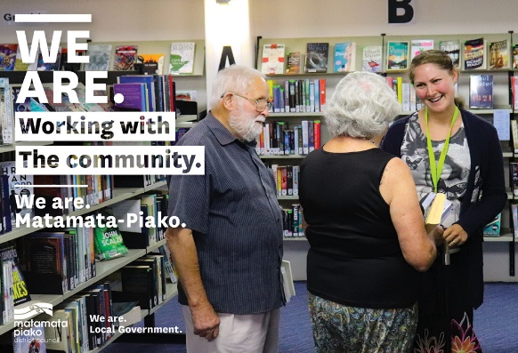

Our mission is to work with the community to enhance the lives of all those in the district.

What we do has a direct effect on our community - the better the quality of our work and the more we work with our community, the better our community will be.

What we do matters.

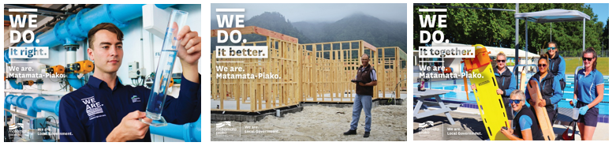**Our Values: We do it right, we do it better, we do it together**

**Expected behaviours**

**We do it right**

* We are accountable for our actions
* We take ownership of our work
* We provide great customer service
* We are professional in all our dealings with others
* We are aware of how our actions reflect on Council
* We are open and honest with each other
* We are trustworthy
* We are responsible for our own wellbeing and the wellbeing of our workmates

**We do it better**

* We are open to learning and change
* We are self motivated and we use our initiative
* We learn from our mistakes
* We challenge the status quo
* We strive for continuous improvement
* We are friendly, helpful and flexible
* We are solution centred

**We do it together**

* We work together as one team
* We respect and accept the views of others
* We are informed and we keep others informed
* We share our knowledge with other teams
* We celebrate success
* We are actively involved as part of the team

**Key accountabilities**

The position of Governance Advisor / Senior Governance Advisor, encompasses the following functions or Key Accountabilities:

* Governance and meeting coordination
* General administration
* Policy, Partnerships and Governance team administration
* Cover and support
* Customer and Community Focus
* Corporate/Organisation Contribution

The requirements in the above Key Accountabilities are broadly identified below:

|  |  |
| --- | --- |
| **Jobholder is accountable for** | **Jobholder is successful when** |
| 1. **Governance and meeting coordination**  * **Coordination of meetings** * Meetings for the year are scheduled using corporate systems such as Infocouncil, Outlook, M365 etc. * Meeting rooms are booked for the year * Set up / pack down of Council Chambers (or meeting room) * Advice is provided to the Chairperson and Committee members before and / or during the meetings * Caterers are fairly scheduled in six month blocks * Comply with relevant legislation * **Agenda creation** * Follow up incomplete reports * Coordinate internal and external presenters * Generate agendas using Infocouncil * Bookmark and upload agendas to the MPDC website and M365 * **Minute creation** * Minutes are created using Infocouncil * Minutes are recorded in accordance with the Local Government Official Information and Meetings Act 1987 (LGOIMA) * **Infocouncil** * Meeting times / dates are appropriated input using Infocouncil functionality * Software is kept up to date, tested and any issues reported to the system provider. * Undertake inductions for new / existing staff within the system | * Meetings are coordinated in accordance with the agreed meeting schedule for the year, and applicable legislation i.e. Waharoa (Matamata) Aerodrome Committee subject to the Ngāti Hauā Claims Settlement Act 2014 * Communicating with appropriate teams to ensure meeting room bookings are complete well in advance of meetings * Advice is provided in accordance with Standing Orders and relevant legislation i.e. LGOIMA, Ngāti Hauā Claims Settlement Act 2014 * Meetings are publicly notified, in newspapers, on the MPDC website etc. in accordance with LGOIMA. * Staff / report writers are provided with a schedule of reports and kept up to date on running times * Chairpersons are aware of the expected times for each meeting at least one day prior * Agenda is sent to applicable Council / Committee members within regulated timeframes * Agenda is completed, book marked and uploaded to the MPDC website and M365 at least 5 working days prior to the relevant meeting (or by the regulated timeframe in accordance with LGOIMA) * Meeting times are communicated to Committee Chairperson and applicable staff * Staff are informed of any actions to arise from their reports to Council / Committee meetings * Positive feedback received by Council / Committee members is relayed to staff * Minutes are completed, book marked and uploaded to the MPDC website and M365 within 5 working days of the meeting. * Minutes from previous meetings are confirmed by each Committee and signed by the Chairperson using Secured Signing. * Minutes and agendas are combined and finalised for record keeping into Content Manager. * Minutes from the previous 12 months are made available for auditing purposes. * Infocouncil dates / times are appropriately scheduled in readiness for report writers * Training is provided to new / existing staff and queries answered in a timely manner |
| 1. **General administration**  * **General administration duties:** * Reports are drafted / prepared when required i.e. staff long service presentations, cover reports etc. * End of year processes are completed, including: * Creating the annual meeting schedule for review * Setting the advertising deadline schedules as per the relevant legislation * Setting up new spreadsheets meetings / catering etc. * Meeting rooms are booked * **Support service for Councillors and Committee members** * Council and committee members meeting and / or mileage claims are checked to ensure accuracy, recorded in Council’s management system and sent to People and Wellness team for payment * A weekly Governance update is sent to Councillors * Requests or enquiries are answered in a timely manner * **Assists with the coordination of Council grants** * Provides the Grants Coordinator and Administration officer support with grant processes, including providing guidance, advice and support services to customers. * Where required purchase orders are created and monitored for grant recipients. * **Assists with the local elections / representation reviews** * Provides the Governance Team Leader support with the local elections and / or representation reviews | * Reports are drafted in accordance with meeting agenda times * The annual meeting schedule is ready for review and distribution to each of the Committees for approval before the end of the year * Councillors / Committee members feel supported * Meeting / mileage claims are processed within the timeframes as required by People and Wellness * Councillors are provided with staff / project updates, agendas and / or minutes and coms in brief (provided by the communications team) each week * The Grants Coordinator and Administration Officer is provided with support when required i.e. data entry, sending correspondence, following up outstanding invoices or completion reports etc. * The Governance Team Leader is provided with support with administration and / or engagements i.e. attending markets to consult |
| **3 Policy, Partnerships and Governance team administration**   * Team administration duties * Where required, data is collected * Databases and registers within Authority are developed and maintained * Where required, support provided to the Policy team on Annual Report, Annual Plan and Long Term Plan development * Coordinating hearings * Provide support in the use of corporate systems such as Content Manager, Authority, Infocouncil and Promapp * Assistance with the consultation and hearing processes | * Data is collected and reported accurately * Proof reading documents provided * Hearing organisation is successfully undertaken i.e. appointments, correspondence and data collection * The team is provided with support with administration and / or engagements i.e. attending markets to consult |
| **4 Cover and support**   * To provide cover and support within the team as directed by your manager including but not limited to: * Local elections * Representation reviews * Annual Report * Annual Plan * Long Term Plan | * Cover and support is provided as required. |
| **5 Customer and Community Focus**   * To ensure that the reputation of Council is enhanced and that a sound relationship with the district community is developed by maintaining an open policy for community participation and the distribution of information. * Ensure customers receive good service over the phone, face to face and through mail and email. * Follow through on Customer Request for Service (CRM) * To ensure cultural perspectives are reflected in all business practices. | * Agreed processes are used to enable a pro-active and positive Council interface with customers. * Availability and readiness to meet and consult with individuals and community groups. * Respond to customers in a timely manner and inform them of progress. No customer complaints received * CRM and RM response times are met. * Evidence of cultural perspectives in consultation, with improved relationships and appropriate protocols observed. |
| **7 Corporate/Organisation Contribution**   * To utilise, maintain and access council information systems ensuring data is current, accurate and available * To maintain the security of the information systems and their content, and to follow policy with regard to the handling of information both electronic and physical. * Comply with all Council’s policies and rules * Work practices to reflect the corporate vision values and expectations * Demonstrate a willingness to participate in special projects. * Foster co-operation between other teams for the benefit of the organisation * Participate in the development, implementation and continual improvement of procedures and standards, to ensure the provision of quality services to both internal and external customers * Assist Councils emergency management response in the event of a civil defence declaration. * Ensure that all Health and Safety requirements as outlined in the Health and Safety policy are complied with. | * That processes associated with information collection, recording, communication and maintenance are followed using the relevant procedures and standards, and following the requirements of the associated policies * That there are no unauthorised breaches of the IT and Records Policies * Complies with all policies and rules * Promote and express pride in your team and the organisation. * Participate, express ideas and viewpoints at team group meetings. * Contribute to corporate initiatives when required. * The quality management system is continually improved and maintained. * Assist in Council’s emergency response actions as required. * Ensure awareness of Health and Safety requirements and procedures. |

***Note***

*The above performance standards are provided as a guide only. The precise performance measures for this position will need further discussion between the jobholder and manager as part of the performance management process.*

**Work complexity**

Most challenging duties typically undertaken:

* Understanding and being able to provide advice on standing orders and relevant legislation to ensure meetings run smoothly and in accordance with relevant legislation.
* Understand Council grants processes and be able to provide advice/guidance to applicants and assess eligibility.
* Communication and managing work.
* Use of corporate software.
* Management of Councils Infocouncil system.
* Management of new databases and registers.
* Coordination/organisation of meetings/hearings for Long Term Plan, Annual Plan and other consultation processes to meet statutory requirements.
* Interpret and comply with all appropriate legislation and meet legislative deadlines.
* Accurately prepare and distribute agendas, reports and minutes in an agreed format, and within designated time constraints.
* Liaise with elected members and appropriately deal with the public and staff.
* Attend and record the minutes at Council, Committees and Hearing meetings.

**Key relationship skills**

|  |  |  |
| --- | --- | --- |
| ***Key internal and/or external contacts*** | ***Nature of the contact most typical***  *(e.g. courtesy, giving/receiving information, explaining things, liaising, advising, gaining cooperation, facilitating, influencing and persuading, resolving minor conflicts, mediating, negotiating, formal negotiation, supervising, leading.)* | ***Frequency of interaction***  *D - daily*  *W - weekly*  *M - monthly* |
| *Mayor and Councillors* | *Courtesy, support & assistance, giving/receiving information, explaining things, advising, gaining cooperation* | *W* |
| *Public* | *Courtesy, support & assistance, giving/receiving information, explaining things, advising, gaining cooperation* | *W* |
| *People and Wellness and Communications Team* | *Courtesy, support & assistance, giving/receiving information* | *W* |
| *Executive Management & Managers* | *Courtesy, giving/receiving information, explaining things, liaising, advising, gaining cooperation, influencing and persuading* | *W* |
| *Staff* | *Courtesy, giving/receiving information, explaining things, reacting to help calls* | *D* |
| *Caterers, suppliers* | *Courtesy, giving/receiving information, explaining things* | *W* |
| *Meeting presenters* | *Courtesy, giving/receiving information, facilitating different technology, liaising, gaining cooperation* | *W* |

Examples of situations which require the use of the highest level of communication or influencing skills:

* Communicating - written and verbal requests from the public and staff during consultation/hearing processes where the team has the highest workload
* Organisational skill - receipt and collation of submissions, organising hearing times/bookings, submissions, notification of LTP etc.
* Training staff in Infocouncil
* Encouraging managers to have their reports ready for Council agendas by deadline
* Giving general advice to Council, staff and the public e.g. meeting protocol and legislative requirements
* Assisting elected members where required

Examples where the role co-ordinates or provides coaching or monitors the work of other people not reporting directly to the role (e.g. contractors)?

Checking documents such as the Long Term Plan etc. for accuracy, spelling, grammar and punctuation and providing feedback to the Policy, Partnerships and Governance team.

**Person specification**

This section is designed to capture the expertise required for the role at the 100% fully effective level. (This does not necessarily reflect what the current jobholder has.) This may be a combination of qualifications/experience, knowledge or equivalent level of learning through experience or key skills, attributes or job specific competencies.

|  |  |  |
| --- | --- | --- |
| Essential | Preferred | |
| **Education and qualifications**   * Full NZ Drivers' Licence | | * Relevant Governance / Local Government Certificates * NCEA level Three (or equivalent Bursary) | |
| **Knowledge and experience**   * Advanced computer literacy i.e. Microsoft (MS) products * Accurate word processing / MS Excel skills with an eye for detail * Good listening skills and ability to record minutes accurately * Ability to communicate effectively with diverse groups of people * Excellent time management skills | | * Prior experience in a similar role |

**Skills & Competencies**

* Attention to detail - ability to accurately check processes , tasks and / or information no matter how small
* Ability to Learn - Shows a willingness to learn and use new processes. Readily takes up relevant training and learning opportunities
* Organisation Skills - Has a systematic approach that leads to the successful completion of tasks and events. Has ability to programme and organise work, and keeps functional records and filing systems in order.
* Quality and Accuracy - Accomplishing tasks with concern for the standard produced; checking own or others’ work to ensure accuracy, adherence to procedures and completeness. Improves processes as required.
* Collaboration - Working effectively with others in the organisation outside the line of formal authority (such as peers in other units or senior management) to accomplish organisational goals.
* Commitment/Personal Accountability - Is self motivating and self managing. Follows through projects to completion. Has high standards of personal integrity and professionalism.
* Relationship with Elected Members – Building effective communication and professional relationships in accordance and within established procedures, practice, code of conduct, or charter.
* Minute taking and facilitating meetings - is familiar with meeting protocol (chairing process, meeting rules, record keeping, closure provisions) and has proven ability in minute taking and agenda preparation

**Change to position description**

From time to time it may be necessary to consider changes in the position description in response to the changing nature of our work environment – including technological requirements or statutory changes. This position description may be reviewed as part of the preparation for performance planning for the annual performance cycle or as required.

Position holder Date