**Position Description**

|  |  |
| --- | --- |
| Job title: | **Consents Engineer** |
| Group: | Growth and Regulation |
| Reports to: | Team Leader Consents Engineer |
| Staff reporting to this position: | No direct reports |
| Position purpose: | To coordinate and provide engineering input for all building and resource consents including monitoring through to section 224 certificate stage. |
| Position grade: | 15 |
| Date: | December 2024 |

**Organisation context**

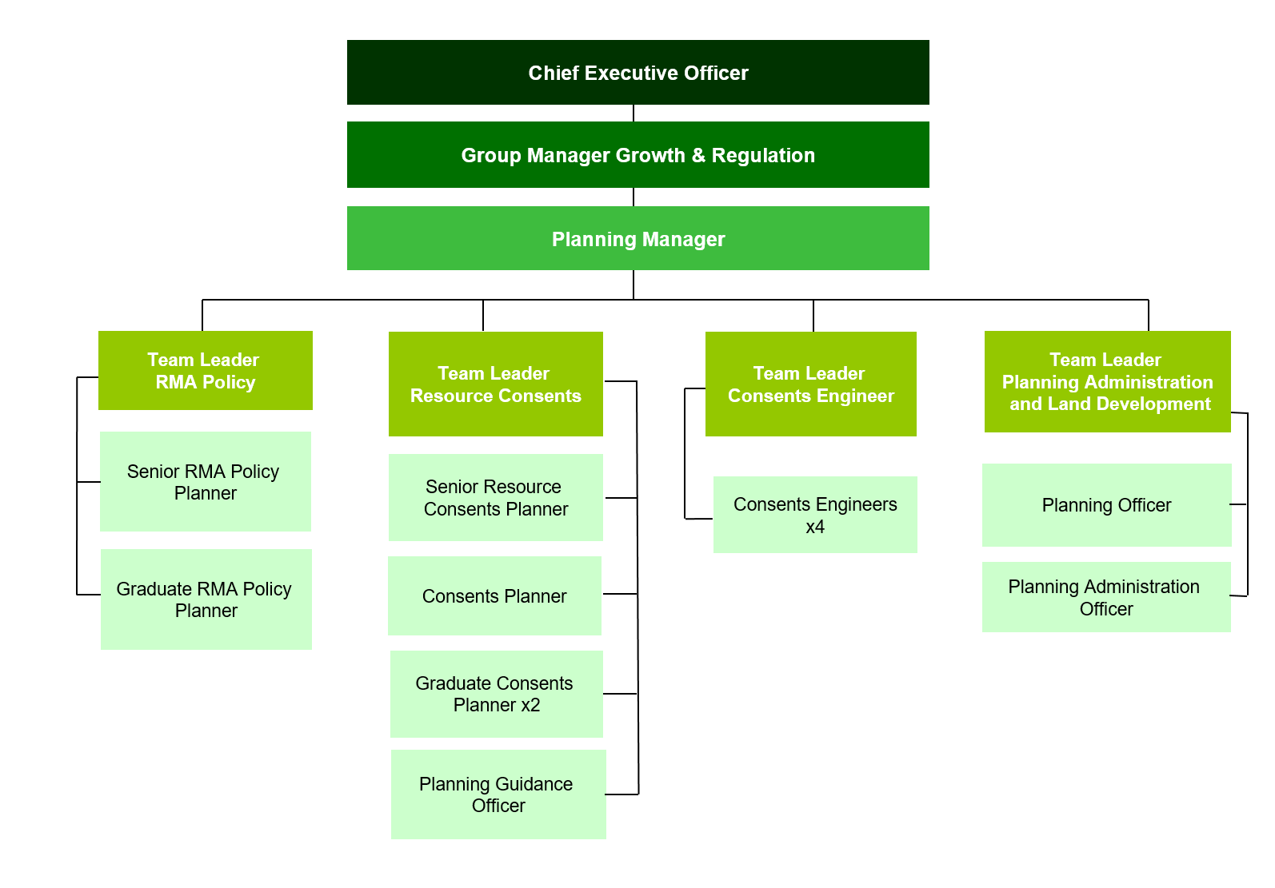

**Our Vision: Making a difference**

We as a Council strive to make a difference in our community in everything we do. In our work, in our district, and in our staff culture.

Making a difference means doing your job to the best of your ability, to improve the district, the towns we live in, and the lives of the people who live in Matamata-Piako.

The way we do things, has a real opportunity to make a difference in the lives of those who live in our communities.

**Our Mission: Working with the community**



Our mission is to work with the community to enhance the lives of all those in the district.

What we do has a direct effect on our community - the better the quality of our work and the more we work with our community, the better our community will be.

What we do matters.

**Our Values: We do it right, we do it better, we do it together**

**Expected behaviours**

**We do it right**

* We are accountable for our actions
* We take ownership of our work
* We provide great customer service
* We are professional in all our dealings with others
* We are aware of how our actions reflect on Council
* We are open and honest with each other
* We are trustworthy
* We are responsible for our own wellbeing and the wellbeing of our workmates

**We do it better**

* We are open to learning and change
* We are self motivated and we use our initiative
* We learn from our mistakes
* We challenge the status quo
* We strive for continuous improvement
* We are friendly, helpful and flexible
* We are solution centred

**We do it together**

* We work together as one team
* We respect and accept the views of others
* We are informed and we keep others informed
* We share our knowledge with other teams
* We celebrate success
* We are actively involved as part of the team

**Key accountabilities**

The position of Consents Engineer encompasses the following functions or Key Accountabilities:

* Engineering assessments for building and resource consents
* Engineering advice and complaints
* Plan approval and construction
* Reporting
* Cover and Support
* Customer and Community Focus
* Corporate/Organisation Contribution

The requirements in the above Key Accountabilities are broadly identified below:

|  |  |
| --- | --- |
| **Jobholder is accountable for** | **Jobholder is successful when** |
| 1. **Engineering assessments for building and resource consents**  * Undertaking minor (up to 10 lots or buildings) engineering assessments, for relevant building and resource consents to ensure compliance with the District Plan. * Coordinating major urban and rural engineering assessments, for relevant building and resource consents to ensure compliance with the District Plan. * Recommending conditions to be imposed on the relevant consents. * Undertaking site visits where required. | • All engineering assessments are completed within five working days.  • The assessments are appropriate to the activity that is being assessed and considers all relevant District Plan matters.  • Conditions recommended are clear, concise and enforceable.  • Site visits are undertaken in a timely and thorough manner. |
| 1. **Engineering advice and complaints**  * Providing advice and support on the engineering requirements of the District Plan. * Investigating engineering complaints as requested and gaining resolution, where appropriate. | • Advice given is sound and provided in a timely manner.  • Complaints are investigated and any transgressions in works or processes corrected.   * All information is documented in the Council’s corporate system in a timely and accurate manner. |
| 1. **Plan approval and construction**  * Assessing, approving or co-ordinating (depending on complexity) the approval of engineering plans and/or compliance with engineering conditions. * Inspecting, approving or co-ordinating, all site works in accordance with the Development Manual, Regional Infrastructure Technical Specifications (RITS) and Infrastructure Code of Practice. | • All information is documented in our corporate system in a timely and accurate manner.  • All engineering plans are processed and approved in accordance with the Development Manual and Infrastructure Code of Practice.  • Correct construction and testing procedures are followed. |
| 1. **Reporting**  * Ensuring data is collected and reports are prepared as required | * Systems are maintained to ensure appropriate data is collected and can be extracted. * Accurate data is collected in the Council’s corporate systems and reports, where required, are produced in a timely and robust manner. |
| 1. **Cover and support**  * Providing cover and support within the Consents Engineer team as directed by the Team Leader. | * Cover and support is provided as required. |
| **6** **Customer and community focus**   * Ensuring that the reputation of Council is enhanced and that a sound relationship with the district community is developed by maintaining an open policy for community participation and the distribution of information. * Ensuring customers receive good service over the phone, face to face and through email. * Following through on Customer Request for Service (CRM). * Ensuring cultural perspectives are reflected in all business practices. | * Agreed processes are used to enable a pro-active and positive Council interface with customers. * Availability and readiness to meet and consult with individuals and community groups. * Customers are responded to in a timely manner and are kept informed of progress. * CRM response times are met. * Evidence of cultural perspectives in consultation, with improved relationships and appropriate protocols observed. |
| **7** **Corporate/organisation contribution**   * Utilising, maintaining and accessing council information systems ensuring data is current, accurate and available. * Maintaining the security of the information systems and their content, and following policy with regard to the handling of information both electronic and physical. * Complying with all Council’s policies and rules. * Demonstrating work practices that reflect the corporate vision values and expectations. * Demonstrating a willingness to participate in special projects. * Fostering co-operation between other teams for the benefit of the organisation. * Participating in the development, implementation and continual improvement of procedures and standards, to ensure the provision of quality services to both internal and external customers. * Assisting with Council’s emergency management response in the event of a civil defence declaration. * Ensuring that all Health and Safety requirements as outlined in the Health and Safety policy are complied with. | * Processes associated with information collection, recording, communication and maintenance are followed using the relevant procedures and standards, and following the requirements of the associated policies. * There are no unauthorised breaches of the IT and Records Policies. * Compliance with all policies and rules is achieved. * The Consents Engineering team and the organisation are promoted. * Ideas and viewpoints are expressed at team and group meetings. * Corporate initiatives are contributed to when required. * Quality management systems are continually improved and maintained. * Assistance is provided to Council’s emergency response actions as required. * Awareness of Health and Safety requirements and procedures is demonstrated. |

***Note***

*The above performance standards are provided as a guide only. The precise performance measures for this position will need further discussion between the jobholder and manager as part of the performance management process.*

**Work complexity**

Most challenging duties typically undertaken:

* Determining whether an activity meets the performance standards of the District Plan and also meets the requirements of the RMA.
* Investigating complaints and mediating between dissolute parties to ensure compliance with rules and policies.

**Key relationship skills**

|  |  |  |
| --- | --- | --- |
| ***Key internal and/or external contacts*** | ***Nature of the contact most typical***  *(e.g. courtesy, giving/receiving information, explaining things, liaising, advising, gaining cooperation, facilitating, influencing and persuading, resolving minor conflicts, mediating, negotiating, formal negotiation, supervising, leading.)* | ***Frequency of interaction***  D - daily  W - weekly  M - monthly |
| Public | Courtesy, giving/receiving information, explaining things to people, clarifying needs, persuading, resolving conflicts, mediating | D |
| Managers | Liaising, giving/receiving information, explaining things | D |
| Customer Services | Liaising, giving/receiving information, explaining things | D |
| Planning | Giving/receiving information/advising/discussing/liaising | D |
| Engineers | Giving/receiving information/advising/discussing/liaising | D |
| Assets and Strategy | Giving/receiving information/advising/discussing/liaising | D |
| Building | Giving/receiving information/liaison/advising | D |
| Applicants | Advising/influencing and persuading/enforcing | D |
| Professional Personnel | Liaising, advising | D |

Examples of the situations which require the use of the highest level of communication or influencing skills:

* Mediation between parties in dispute over RMA matters, writing legal notices, attempting to gain compliance.
* Conflict resolution.

**Person specification**

This section is designed to capture the expertise required for the role at the 100% fully effective level. (This does not necessarily reflect what the current jobholder has.) This may be a combination of qualifications/experience, knowledge or equivalent level of learning through experience or key skills, attributes or job specific competencies.

|  |  |
| --- | --- |
| Essential | Preferred |
| **Education and qualifications**   * Full NZ Drivers Licence * NZC in engineering or equivalent relevant experience | * Relevant engineering degree |
| **Knowledge and experience**   * At least 3 years practical experience in a related field. * Experience in Council building control and/or planning consent processes. * Basic engineering knowledge of roading and earthworks systems. * Basic engineering knowledge of utility systems as they affect building and subdivisions. * Basic engineering knowledge/design of stormwater systems. | * Experience in Local Government. * Experience in an engineering environment. * Experience in roading and earthworks systems. * Experience in utility and stormwater systems in a Council environment. * Has a demonstrated working knowledge of legislation relevant to the position and is able to apply that knowledge, particularly in relation to the Building Act, Local Government Act and Resource Management Act. |

**Skills & Competencies**

* Interpersonal Skills - Establishing and maintaining relationships with staff, customers and suppliers to improve the overall effectiveness of the position.
* Collaboration - Working effectively with others in the organisation outside the line of formal authority (such as peers in other units or senior management) to accomplish organisational goals.
* Attention to detail - ability to accurately check processes, tasks and/or information no matter how small over time yet still showing concern for all the other aspects of the job.
* Commitment/Personal Accountability - Is self-motivating and self-managing. Follows through projects to completion. Has a high standard of personal integrity and professionalism.
* Decision making / Problem Solving - Is able to analyse and solve complex problems, form judgements and make decisions within known parameters. Can resolve conflict or differences of opinion.
* Communication - Clearly conveys information and ideas through a variety of appropriate media to individuals or groups in a manner that helps them understand and retain the message. Communicates in a compelling and articulate manner that instils commitment

**Change to position description**

From time to time it may be necessary to consider changes in the position description in response to the changing nature of our work environment – including technological requirements or statutory changes. This position description may be reviewed as part of the preparation for performance planning for the annual performance cycle or as required.

Position holder Date