**Position Description**

|  |  |
| --- | --- |
| Title | Team Leader – Consents Engineer |
| Group: | Growth and Regulation |
| Reports to: | Planning Manager |
| Number of staff reporting to this position: | Four |
| Position purpose: | To coordinate and provide engineering input into resource and building consent applications, undertake inspections and answer customer enquiries in accordance with Council’s policies and legislative requirements.  To provide technical management for consents engineering staff. |
| Position Grade: | 17 |
| Date: | October 2024 |

**Organisation context**

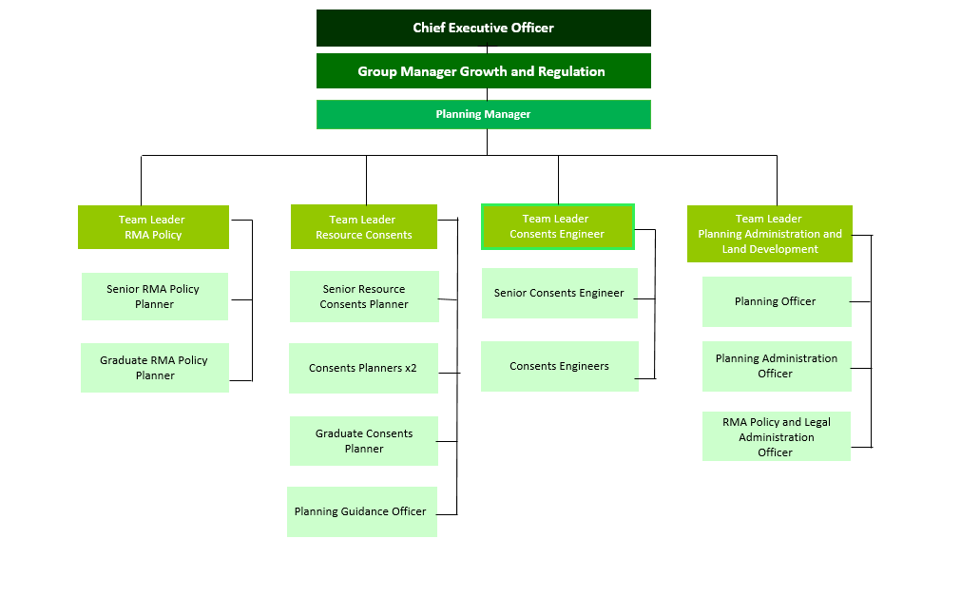

**Our Vision: Making a difference**

We as a Council strive to make a difference in our community in everything we do. In our work, in our district, and in our staff culture.

Making a difference means doing your job to the best of your ability, to improve the district, the towns we live in, and the lives of the people who live in Matamata-Piako.

The way we do things, has a real opportunity to make a difference in the lives of those who live in our communities.

**Our Mission: Working with the community**



Our mission is to work with the community to enhance the lives of all those in the district.

What we do has a direct effect on our community - the better the quality of our work and the more we work with our community, the better our community will be.

What we do matters.

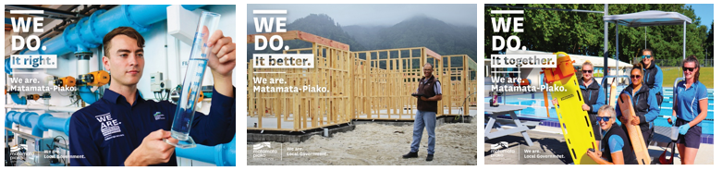**Our Values: We do it right, we do it better, we do it together**

**Expected behaviours**

**We do it right**

* We are accountable for our actions
* We take ownership of our work
* We provide great customer service
* We are professional in all our dealings with others
* We are aware of how our actions reflect on Council
* We are open and honest with each other
* We are trustworthy
* We are responsible for our own wellbeing and the wellbeing of our workmates
* We are approachable, direct, open and honest when communicating with others
* We lead by example and demonstrate our vision and values in all that we do

**We do it better**

* We are open to learning and change
* We are self motivated and we use our initiative
* We learn from our mistakes
* We challenge the status quo
* We strive for continuous improvement
* We are friendly, helpful and flexible
* We are solution centred
* We enable and trust our team to make decisions, display initiative and take risks
* We actively encourage our team to broaden their skills and reach their full potential

**We do it together**

* We work together as one team
* We respect and accept the views of others
* We are informed and we keep others informed
* We share our knowledge with other teams
* We celebrate success
* We are actively involved as part of the team
* We are clear on where our team is heading and what we need to achieve
* We use delegation as an effective management tool
* We actively encourage working together and respecting other teams

**Key accountabilities**

The position of Team Leader - Consents Engineer encompasses the following functions or Key Accountabilities:

* Engineering assessments for building and resource consents
* Engineering advice and investigation of complaints
* Plan approval and construction
* Health and Safety
* Customer and Community Focus
* Corporate/Organisation Contribution
* Team Performance and Leadership

The requirements in the above Key Accountabilities are broadly identified below:

|  |  |
| --- | --- |
| **Jobholder is accountable for** | **Jobholder is successful when** |
| **1 Team Performance and Leadership**   * Providing leadership, support and development for the team by setting clear and consistent standards, developing and empowering others, building commitment and trust, addressing performance related issues, managing conflict and building effective teams. * Effectively leading the team in its support of the executive and delivery of agreed programmes and services      * Leading the successful implementation of Corporate and People, Safety and Wellness initiatives. * Promoting and maintaining a culture that achieves a high level of morale within the team and encourages performance, productivity, openness, employee satisfaction and trust. * Encouraging team members to demonstrate Council's vision and values in their work * Ensuring the team are complying with the requirements of the Project and Procurement Management systems and Contract Procedures Manual as they apply to the procurement of works or services for Council. * Ensuring that the team is familiar with the requirements of the risk management process and regularly consider the risks of the works or services they are undertaking on behalf of Council. | * Meaningful performance reviews are held (MPDC’s Mariner7 process). Training and development needs are identified and development plans are in place for the team. * Performance improvement plans are in place to ensure poor performance is managed in an effective manner. * 360 reporting and other feedback reflects effective people and performance management and team engagement. * All positions are filled by suitably qualified and competent staff. * Corporate and People, Safety and Wellness policies, processes, procedures and systems are used and followed on time and to standard, e.g. accurate checking and authorisation of time sheets, GPS readings, management of annual leave (including approving online leave weekly) etc. * Evidence points to a competent, motivated and professional workforce, performing efficiently and effectively and demonstrating Council’s vision and values in their work. * Team members comply with the requirements of the Project and Procurement Management systems and Contract Procedures Manual * Team members are familiar with the requirements of the risk management process and when required risks are considered. |
| **2 Engineering assessments for building and resource consents**   * Undertaking engineering assessments on all resource and building consents for minor developments (generally those under 10 dwelling / lots and no new assets vested other than connections) to ensure all developments are in accordance with the RMA, Council’s District Plan, Development Manual, Infrastructure Code of Practice, Bylaws and Regional Infrastructure Technical Specifications. * Managing Council’s engineering response (including co-ordination with the Asset Team) for all major resource consents (generally those over 10 dwellings / lots and/or vested assets) to ensure all developments are in accordance with the RMA, Council’s District Plan, Development Manual, Infrastructure Code of Practice, Bylaws and Regional Infrastructure Technical Specifications. * Recommending appropriate conditions to be imposed on the relevant resource consents. * Undertaking site visits where required. | • All engineering assessments including requests for further information are completed within agreed timeframes.  • The assessments are appropriate to the activity that is being assessed and considers all relevant District Plan matters.  • Conditions recommended are clear, concise and enforceable.  • Site visits are undertaken in a timely and thorough manner. |
| **3 Engineering advice, complaints and monitoring**   * Providing advice and support on the engineering requirements of the District Plan. * Investigating engineering complaints as requested and gaining resolution. * Monitoring resource consents conditions for compliance. * Liaising and building relations with other relevant departments for example the Building and Asset teams | • Advice given is sound and provided in a timely manner.  • Complaints are investigated and any transgressions in works or processes corrected.   * All information is documented in the Council’s corporate system in a timely and accurate manner. * The Building and Asset teams are met with regularly to share information |
| **4 Plan approval and construction**   * Assessing engineering design plans to ensure assets to be vested in Council comply with Council’s specifications, including to negotiate changes where required and approved final engineering design plans for construction. * Inspecting and approving all site works to ensure all assets are constructed in accordance with the Development Manual, Infrastructure Code of Practice, Bylaws and Regional Infrastructure Technical Specifications. * Ensuriing all as-built data is accurate and documented in accordance with Council’s requirements. * Ensuring all information including documentation is entered into the Council’s corporate systems accurately and in a timely manner. | • All information is documented in the Council’s corporate system in a timely and accurate manner.  • All engineering plans are processed and approved in accordance with the Development Manual and Infrastructure Code of Practice or Regional Infrastructure Technical Specifications.  • Correct construction and testing procedures are followed. |
| **5 Customer and Community Focus**   * Ensuring that the reputation of Council is enhanced and that a sound relationship with the district community is developed by maintaining an open policy for community participation and the distribution of information. * Ensuring customers receive good service over the phone, face to face and through email. * Following through on Customer Requests for Service (CRM) * Ensuring cultural perspectives are reflected in all business practices. | * Agreed processes are used to enable a pro-active and positive Council interface with customers. * An availability and readiness to meet and consult with individuals and community groups is demonstrated. * Customers are responded to in a timely manner and are informed of progress. * CRM and RM response times are met. * Evidence of cultural perspectives is shown in consultation, with improved relationships and appropriate protocols is observed. |
| **6 Corporate/Organisation Contribution**   * Utilising, maintaining and accessing Council information systems ensuring data is current, accurate and available * Maintaining the security of the information systems and their content, and following policy with regard to the handling of information both electronic and physical. * Complying with all Council’s policies and rules. * Reflecting the corporate vision values and expectations in their work practices. * Demonstrating a willingness to participate in special projects. * Fostering co-operation between other teams for the benefit of the organisation * Participating in the development, implementation and continual improvement of procedures and standards, to ensure the provision of quality services to both internal and external customers * Assisting Council’s emergency management response in the event of a civil defence declaration. * Ensuring that all Health and Safety requirements as outlined in the Health and Safety policy are complied with. * Ensuring compliance with relevant legislation | * Processes associated with information collection, recording, communication and maintenance are followed using the relevant procedures and standards, and following the requirements of the associated policies * There are no unauthorised breaches of the IT and Records Policies. * Compliance is achieved with all policies and rules. * The team and the organisation is promoted. * Ideas and viewpoints are shared at team group meetings. * Corporate initiatives are contributed to when required. * The quality management system is continually improved and maintained. * Council’s emergency response actions are contributed to as required. * Health and Safety requirements and procedures are acknowledged and adhered to. * Relevant legislation is complied with as per Council’s Legislative Compliance Schedule. |

***Note***

*The above performance standards are provided as a guide only. The precise performance measures for this position will need further discussion between the jobholder and manager as part of the performance management process.*

**Work complexity**

Most challenging duties typically undertaken:

* Ensuring compliance with technical requirements
* Investigating complaints and mediating between dissolute parties to ensure compliance with rules and policies.
* People management

**Key relationship skills**

|  |  |  |
| --- | --- | --- |
| ***Key internal and/or external contacts*** | ***Nature of the contact most typical***  *(e.g. courtesy, giving/receiving information, explaining things, liaising, advising, gaining cooperation, facilitating, influencing and persuading, resolving minor conflicts, mediating, negotiating, formal negotiation, supervising, leading.)* | ***Frequency of interaction***  D - daily  W - weekly  M - monthly |
| Planning Manager | Give and receive information, explain things, liaise, advise, courtesy | D |
| Planning Team | Give/receive information, give direction, explain things, advising, gaining cooperation, courtesy | D |
| Staff | Give and receive information, courtesy, explain things, advise, persuade and influence, facilitating, gaining cooperating | D |
| Legal team / Assets / Building / Roading / Three Waters / Customer Services | Give and receive information, explain things, liaise, advise | D |
| Consultants | Give and receive information, explain things, liaise, advise | W |
| Public | Give and receive information, explain things, liaise, advise, influence and persuading, courtesy, negotiation | D |

Examples of the situations which require the use of the highest level of communication or influencing skills:

* public meetings
* high profile resource consents
* providing technical advice to engineering staff
* resolving engineering solutions with applicants / developers / surveyors
* working with customers to recertify non-compliance

Examples where the role co-ordinates or provides coaching or monitors the work of other people not reporting directly to the role (e.g. contractors).

* Planners / Roading / Asset Team / Three Waters / Building Team – provide interpretation / guidance on the engineering requirements.

**Person specification**

This section is designed to capture the expertise required for the role at the 100% fully effective level. (This does not necessarily reflect what the current jobholder has.) This may be a combination of qualifications/experience, knowledge or equivalent level of learning through experience or key skills, attributes or job specific competencies.

|  |  |
| --- | --- |
| Essential | Preferred |
| **Education and qualifications**   * National Certificate or Diploma in Civil Engineering | * Degree in Engineering |
| **Knowledge and experience**   * Four years civil engineering * Relevant knowledge of statutory requirements i.e. RMA * Good understanding of other relevant legislation e.g. Local Government Act, Health Act, Building Act | * Engineering experience within a local government environment * One - two years’ experience in a Senior Engineering role * Proven staff management experience |

**Skills & Competencies**

* Interpersonal Skills - Establishing and maintaining relationships with staff, customers and suppliers to improve the overall effectiveness of the position
* Teamwork - Actively participates as a member of a team. Contributes actively and fully to team projects by working with colleages collaboratively, working towards consensual solutions that enhance the output of the team. Accepts share of workload.
* Oral Communication - Expressing ideas effectively in individual and group situations; adjusting language of terminology to the caharacteristics and needs of the audience
* Decision making/Problem solving - Making timely decisions; judgements; taking action when appropriate and committing to a position or direction
* Adaptability - Understanding and appreciating different and opposing perspectives on issues: adapting an approach as the requirements of the situation change.
* Collaboration - Working effectively with others in the organisation outside the line of formal authority (such as peers in other units or senior management) to accomplish organisational goals.

**Change to position description**

From time to time it may be necessary to consider changes in the position description in response to the changing nature of our work environment – including technological requirements or statutory changes. This position description may be reviewed as part of the preparation for performance planning for the annual performance cycle or as required.

Position holder Date