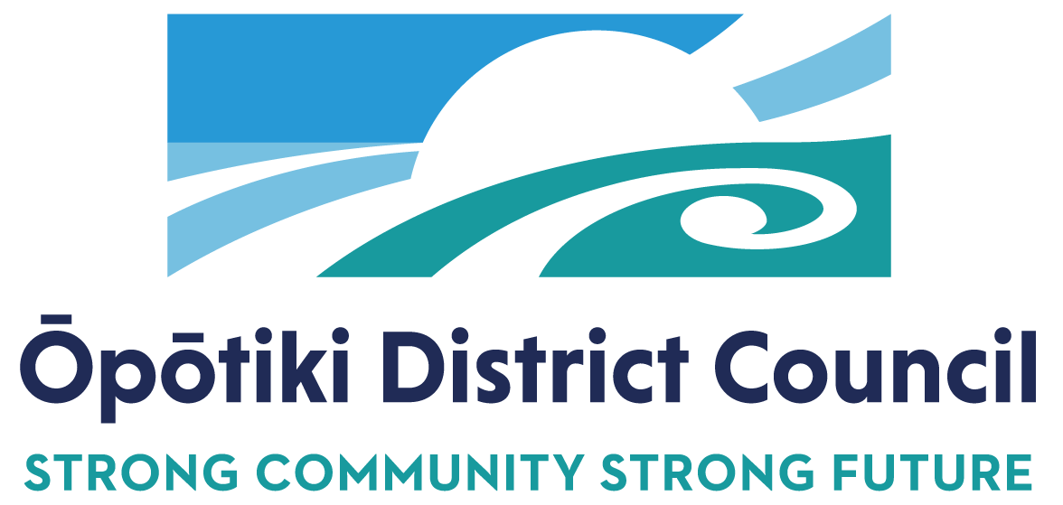

**POSITION DESCRIPTION**

|  |  |
| --- | --- |
| **Job Title:** | **Strategy and Policy Manager** |
| **Responsible To:** | Group Manager Strategy and Development |
| **Responsible For:** | Strategy and Policy Teams: including the following direct reports:   * Strategic Policy Analyst * Strategy and Policy Administrator * Places and Spaces Planner (Fixed Term) * Workforce Coordinator * Strategic Partnerships and Relationships Lead (future role) * Economic and Social Development Lead (future role) |
| **Position Purpose:** | This job exists to:  *Oversee strategy and policy development for Council alongside shaping and leading an activity that contributes to the enhancement of cultural, social, economic and environmental wellbeing for the district.*  *Lead the development and delivery of the strategic direction of Council through the implementation and monitoring of Council Long Term Plan and other special plans and projects.*  *Ensure policy advice and development is undertaken and implemented to support the strategic direction of Council while ensuring that a best practice approach is taken.*  *Provide effective line management to direct reports to support the achievement of their work programmes.* |
| **Date:** | September 2024 |

ORGANISATION CONTEXT

IMPORTANT FUNCTIONAL RELATIONSHIPS

|  |  |
| --- | --- |
| **External** Residents and ratepayers  Council customers  Various government agencies and other councils  Project stakeholders  Iwi and hapū  Consultants and contractors  Developers  Economic Development Agency | **Internal** All staff  Elected members |

KEY RESULT AREAS

The position of **Strategy and Policy Manager** encompasses the following functions or Key Result Areas:

|  |  |
| --- | --- |
| **Jobholder is accountable for** | **Jobholder is successful when** |
| **Partnership Development**   * Identify and develop partnerships with key national and regional stakeholders, including central government and industry * Work with neighbouring councils to set shared priorities and work together strategically and tactically to maximise benefits * Seek out opportunities and identify and attract alternate sources of funding to deliver initiatives to support the development of the district * Ensure our stakeholders (including our community) are regularly and proactively kept informed of development opportunities and projects in Ōpōtiki. | * Council’s interests are represented in regional and sub-regional development forum and strategies * Shared opportunities are identified and acted upon * Funding applications meet the criteria and are to a high professional standard. * Stakeholders are informed and provided with the necessary information regarding opportunities and projects |
| **Strategic Planning and Development**   * Lead the non-financial aspects of the Long-term and Annual Plan processes * Contribute to the design and development of Council strategic plans to ensure economic, social, environmental, and cultural development and growth * Influence policy and strategy development within Council and with external agencies * Commission and carry out research which will track, monitor and evaluate in order to assist with future development and initiatives. | * Councils strategic planning is fit for purpose and supports development and growth of our district * Leadership and expertise is provided for in the Long-Term Plan and Annual Plan processes * Growth and policy trends are identified and considered, and are based on sound evidence, and analysis * Reporting is produced to confirm economic and social development performance and which identifies future opportunities and initiatives. |
| **Project Management**   * Lead and implement projects as required * Work with both internal and external stakeholders to ensure project success * Help to identify and seek funding to initiate strategic/ development projects within the Ōpōtiki District * Ensure projects comply with all relevant legislation * Ensure Council is proactively supported and informed of required decisions, opportunities and risks * Develop and maintain detailed project strategies, plans and budgets for development projects * Prepare and maintain clear project proposals, define scope and work plans * Evaluate progress, problem solve if needed and identify improvements. | * Robust and clear advice and reports are produced in accordance with Council and/or other specified timeframes * Compliance is achieved and financial and reputational risk is minimised, for example resource management, building and engineering standards, health and safety * Project stakeholders are engaged and informed on progress and where necessary risk * High quality projects are delivered within budget and are a sound investment of expenditure. * Work is undertaken within and according to the established work plans * Risk and stakeholder expectations are well managed * Projects are completed within budget, to agreed standard, polices adhered to, variances justified * Managers, staff and other stakeholders provide good feedback and issues are resolved. |
| **Policy Development**   * Lead policy advice and guidance processes to Council to support informed decision making * Lead the undertaking of research that pertains to relevant policy issues to ensure robust policy development and implementation * Ensure a robust processed is undertaken for submissions working with key stakeholders as required. * Monitor legislative requirements to ensure Council policy and plans meet obligations and are fit for purpose * Ensure the community and key stakeholders are provided with opportunities to participate the development of policies and plans for the district. | * Research, analysis, conclusions and recommendations are sound and inform Council decision making * Opportunities for collaborative planning are identified * Submissions on Bills and discussion documents are prepared on time, are well researched and reflect Council’s interest * Council and other stakeholders are proactively informed to legislative changes / requirements * Consultation strategies are appropriate and result in stakeholders and community understanding the policy development and decision-making processes. |
| **Relationships/communication**   * Ensure the relationship between the Council and its key external stakeholders is positive and constructive * Represent Council at appropriate events, meetings and conferences * Building effective and meaningful relationships with the other staff across Council. * Positively present and promote Council’s processes, initiatives and actions to other Council staff, elected members, key stakeholders and the community using appropriate communication channels * A range of communication mechanisms are utilised to proactively inform and involve the community of opportunities, projects and plans | * Customers are satisfied and feedback is complimentary * Relationships with key decision-makers and opinion leaders in the community is positive and constructive * Communications material is well managed, accessible and filed appropriately. * Informal and formal consultation process are proactively undertaken * Effective relationships are maintained with stakeholders * Presentations are well researched, and appropriate for the audience * Enquiries or requests for information from customers are actioned promptly. |
| **Leadership**   * Positively and proactively leads the Strategy and Policy team including providing ongoing mentoring, training and coaching to staff * Leads and maintains a strong focus on continuous improvement through effective planning, monitoring and evaluation processes * Participates fully in the performance management processes including working with direct reports to develop, monitor and review work performance * Appropriately manages leave balances. * Creates and maintains strong professional networks locally, regionally and nationally. | * The Strategy and Policy team is positive, thriving and engaged in their work * Continuous improvement is evident across the planning and delivery of services * Processes and systems are in place which support the delivery of outcomes * Performance appraisal completed and actioned for all staff * Leave balances do not exceed 6 weeks, unless express approval is given by Chief Executive * Professional networks are utilised in increase skills, knowledge and seek advice and guidance as needed. * Proactively seeks support and guidance from their leader. |
| **Health & Safety**   * Provide leadership and encouraging commitment in all work areas to health, safety and well-being * Contribute to Council’s policy, practice and systems to ensure compliance with the legislation, regulations, approved codes of practice, information, guidance and advice * A team health and safety culture which is proactive and constructive. | * Reporting of events, investigation of events and monitoring of work areas, including contractors and volunteers takes place according to Council’s polices and practice * There is a culture of continuous improvement * Internal and external auditing outcomes are positive and complimentary. |
| **Personal Development**   * Develop and maintain professional knowledge and contacts. | * Identify and undertake sufficient training to maintain knowledge to undertake allocated tasks * Attend training opportunities relevant to position and the Council. |
| **Civil Defence**   * Undertake necessary training to ensure   Preparedness for Emergency Management. | * Support is provided during an emergency. |

**Other duties expected of position holder:**

Undertake any other duties and functions as may be requested of you by your Manager.

**Note:**

The above performance standards are provided as a guide only. The precise performance measures for this position will need further discussion between the jobholder and manager as part of the performance management process.

PERSON SPECIFICATION

* Relevant tertiary qualification, e.g. public policy, planning, commerce or related field
* A minimum of 5 years local government experience
* At least 3 years’ experience in strategy and policy development
* Line management experience
* Proven experience in the preparation of advice and development of robust and concise reports for decision makers
* Good overall knowledge of relevant local government legislation
* Evidence of working collaboratively with a range of people and organisations in the delivery of projects or outcomes
* High level of computer literacy using Microsoft Office
* Proven experience managing projects.

**Key Job Competencies**

* Professional and courteous manner
* Strong communication and relationship management skills
* High level of professionalism, honesty, integrity and reliability
* Good planning and time management skills, plans ahead, prioritises, is organised and able to work on multiple projects
* Supports others to achieve their KPIs through proactive leadership and management
* Can effectively problem solve and make decisions
* Resilient and able to cope under pressure
* Appreciation for the political and sensitive nature of Local Government.

Manager Date

Position Holder Date