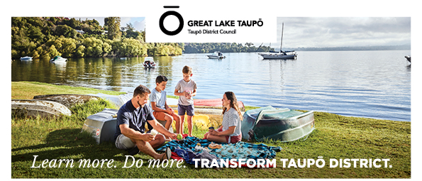
RESOURCE CONSENT PLANNER - MONITORING (FIXED TERM – 18 MONTHS) | TAUPŌ

Are you ready to broaden your experience and contribute to shaping the future of our district?

We have an exciting fixed-term opportunity for a Resource Consents Planner – Monitoring to join our team (until 31 December 2027). This role offers a unique blend of resource consent monitoring, compliance, enforcement, consent processing, and customer engagement, making it an excellent development opportunity for someone looking to broaden their experience within the planning and regulatory environment.

ABOUT THE ROLE – NGĀ ĀHUATANGA O TE TŪRANGA
You'll work across the district to ensure resource consent conditions are being met, investigate complaints, provide advice to customers and stakeholders, and process land use consents. You'll be part of a collaborative team committed to supporting sustainable development and positive community outcomes.

Your key responsibilities will include:
- Monitoring and auditing compliance with resource consent conditions.
- Investigating District Plan complaints and responding to incidents.
- Resolving non-compliance through appropriate enforcement tools.
- Reviewing and processing resource consent applications.
- Undertaking site visits and preparing professional planning reports.
- Providing practical advice to applicants, developers, consultants, and the community.
- Building effective relationships with internal and external stakeholders.
- Contributing to continuous improvement of monitoring, compliance, and enforcement systems and practices.

WHO WE ARE LOOKING FOR - KEI TE KIMI MĀTOU I TĒNEI MOMO TANGATA
We're keen to hear from you if you are looking to take the next step in your career and bring:
- Experience working in a compliance, regulatory, or legislative environment
- Strong written and verbal communication skills.
- The ability to build positive relationships and navigate challenging conversations.
- Sound analytical and problem-solving skills.
- A proactive approach to learning and continuous improvement.

Beyond that, what really matters is how you approach your work – positivity, a willingness to learn, and the confidence to work independently within a supportive team environment.

This is a fantastic opportunity to broaden your planning, compliance, and regulatory experience while contributing to the sustainable development of our district. If you're ready to build on your existing skills and take the next step in your career, we'd love to hear from you.

CLOSING DATE: 7 August 2026 or when the vacancy is filled.

